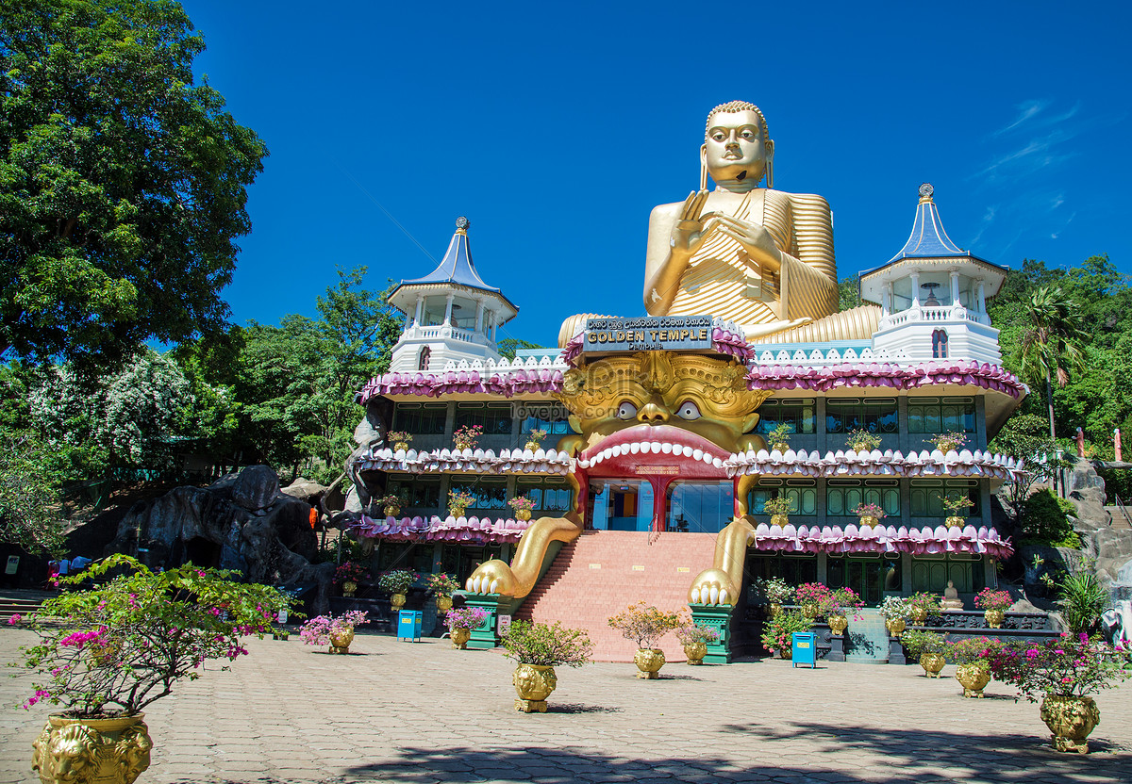

Overview
Sri Lanka, historically known as Ceylon, and officially the Democratic Socialist Republic of Sri Lanka, is an island country in South Asia. It lies in the Indian Ocean, southwest of the Bay of Bengal, separated from the Indian peninsula by the Gulf of Mannar and the Palk Strait. Sri Lanka package from Nepal that takes them away for a ride with nature and wildlife, rich culture and history, and ancient heritage and religion, then Kandy is the one place in the world to be. Attracting people from around the globe with beautiful long-stretch beaches and rugged rain-forests, exquisite botanical and wildlife preservation, ancient structures and art of healing (Ayurveda), and fun-filled water sports and cuisine that tickles every taste buds, Kandy is a dreamland for adventurer, nature enthusiast, and fun-seekers alike that never runs out of ways to impress its visitors.

Tour Itinerary

Day 1: Welcome to Kandy
Arrive in Kandy via flight and prepare yourself for the natural getaway you have been longing. Upon arrival to Kandy, you will be welcomed by our representative who will accompany you on a drive towards your hotel and help you check in at your hotel.
Kandy – a lovely city in Sri Lanka and a sacred Buddhist site is a plateau surrounded by mountains that is most popularly known to the world as home for biodiversity of rainforests. Basically known for its natural abundance, one can almost get lost in its beauty. Kandy is the city of the Temple of the Tooth Relic of Lord Buddha and the best place to witness a traditional Kandyan Dance & Fire Walking. Places like Peradeniya Botanical Gardens and the Mahaweli Diversion Project are the main tourist attractions in Kandy along with Spice Gardens, Gem Museum, etc. A wholesome trip later of this beautiful city and strolling through the scenic Kandy Lake (Bogambara Lake) and gardens, you will be escorted by the tour guide to your hotel.
Upon arrival at the hotel, you will enjoy unique Sri Lankan hospitality and delicious dinner and spend a peaceful comfortable overnight stay in Kandy.
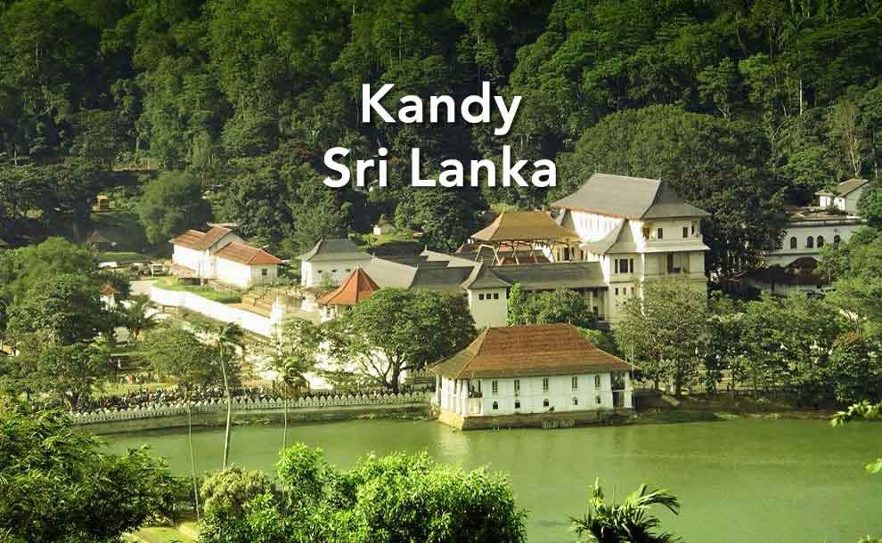

Day 2: Kandy to Bentota
After a pleasingly night-stay in Kandy, now its time we explore Bentota. Have a nice and pleasant breakfast to start off the day.
Soon after breakfast, we will leave for Bentota. You will be visiting Spice Garden in Mawanella. Feast your eyes with beautiful gardens, feel the plants, smell the flowers. It’s a blessing these days to be surrounded by nature, have your fill! Explore nature as never before visiting Pinnawala Elephant Orphanage along the way. Arrive Bentota, a resort town in Sri Lanka. Enjoy long beach stretches, indulge in water sports nowhere else to be found, observe ancient art of healing called Ayurveda.
A pleasing day of travel and nature later, you will be escorted to your hotel in Bentota for a warm delightful Dinner and an overnight stay.
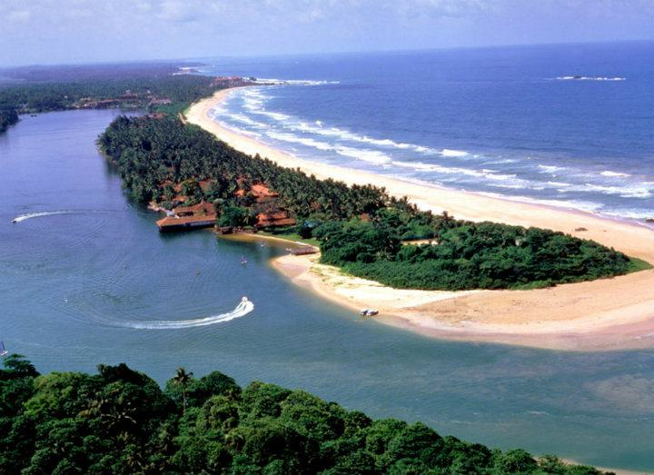

Day 3: More of Bentota
Greet the blissful morning with a satisfied heart. Breakfast will be served at the hotel; have a plentiful as a whole day of exciting adventures is yet to come.
We will be visiting and observing the southern coastal line filled with Turtle Hatchery – the beaches of Sri Lanka are the nesting grounds for five species of marine turtles. Observe and enjoy the beautiful coastal lines, coral-rich dive sites, centuries-old statues and temples, and many more. There is a provision for optional visit to Madu River Boat Safari to enjoy stunning view and great photograph opportunities.
After embracing the nature at its fines, head back to hotel for a fine dining experience and a cozy overnight stay at your hotel.
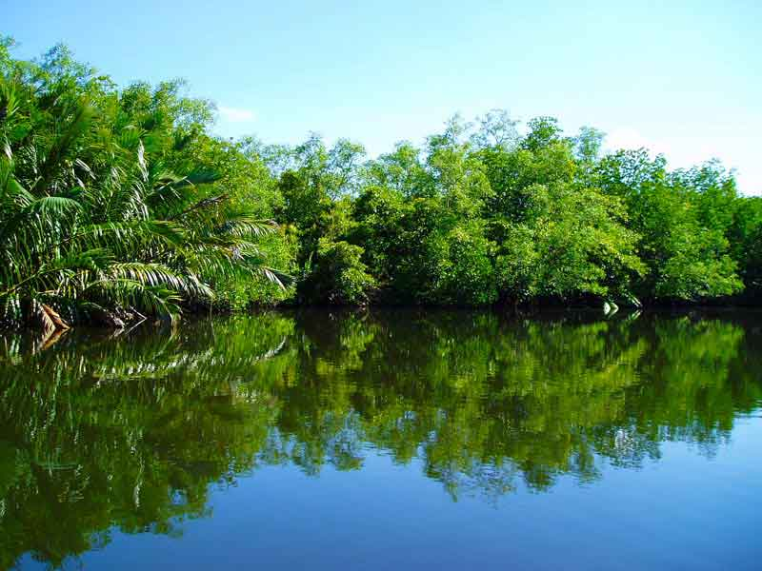

Day 4: Bentota to colombo
Today, we will be traveling to Colombo from Bentota as our next destination. After a heavenly experience of delicacies for breakfast, it is leisure time at the hotel/beach.
Enjoy the beach as much as you can, get a much-needed relaxing time, do whatever you feel like. Later, you will be escorted by the tour guide for a travel to Colombo. Taking a scenic route to Colombo alongside the nature will be the experience you will keep for a lifetime. Nothing is as soothing as nature especially when in Sri Lanka.
After arrival at the hotel in Colombo, you will check in, relax, chill, enjoy the superb hospitality and dinner, and prepare for an overnight stay.
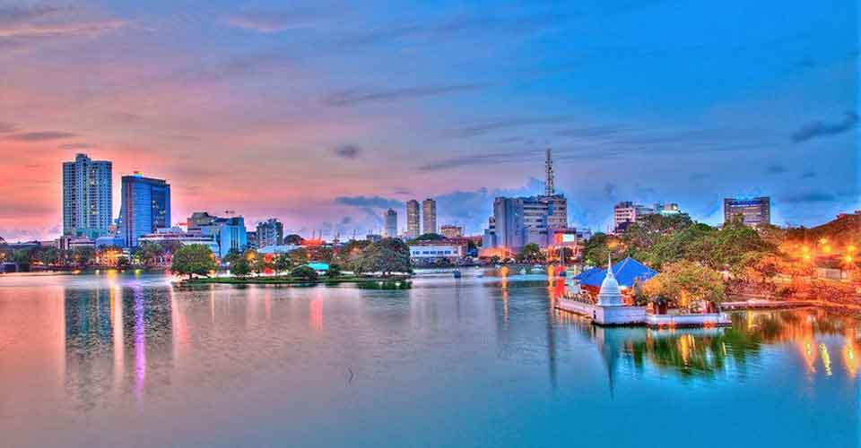

Day 4: colombo
Up and about early for the last day of the tour. Sumptuous breakfast at the hotel will be followed by a city round tour of Colombo.
A drive through the city taking you to the busy commercial areas as well as the tree-lined residential, Cinnamon Gardens will keep you in awe. Visit Fort, the former British Administrative Center and Military Garrison, Sea Street – the Goldsmith’s quarters in the heart of Pettah, the Bazaar area, astonishing Hindu Temples with elaborate stone carvings, and the centuries-old Dutch Church of Wolfendhal dating back to 1749. Also, explore the convention centre, BMICH (Bandaranaike Memorial International Conference Hall) and observe the replica of Avukana Buddha and Independence Square.
After a long tour visiting different world-renowned tourism sites of Colombo, you will head to Colombo Airport for departure to your home to be with your loved ones and share the great memories that you experienced with us in Sri Lanka.
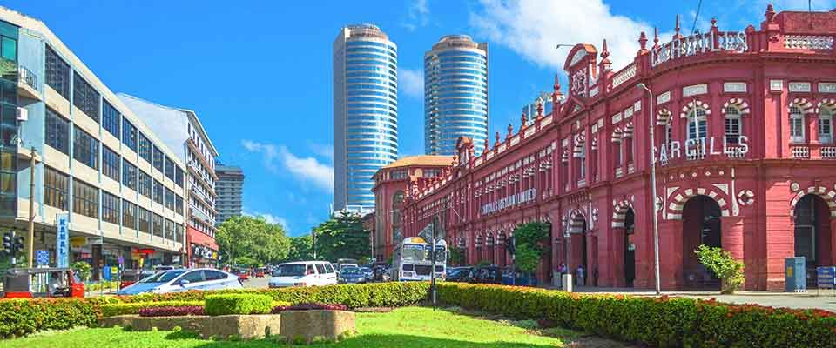

Inclusions
- 1 Night Accommodation in Kandy on BB Basis
- 2 Nights Accommodation in Bentota on BB Basis
- 1 Night Accommodation in Colombo on BB Basis
- Air Fare
- Mentioned Sightseeing as per Itinerary

Exclusions
- Lunch and Dinner
- Expenses of Personal Nature
- Visiting Fee
- Tip for local Guide recommended

