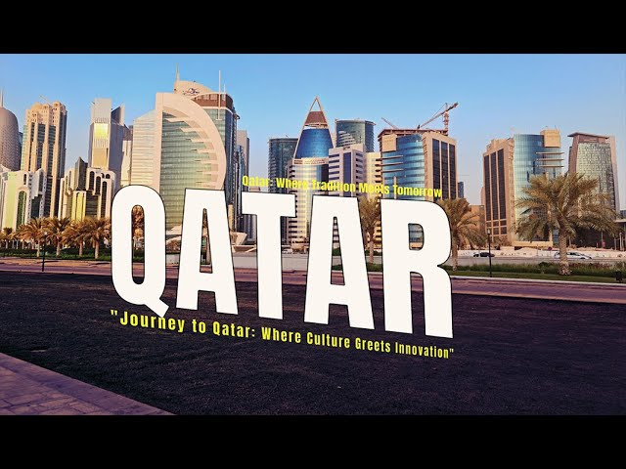

Overview Highlights Itinerary Hotel Inclusions Exclusions Policy

Overview
These Qatar tour packages welcome you to enjoy your dream holiday. Nurtured by the tides of the Arabian Gulf, Qatar is one of the richest countries in the world. The country is also a fast developing nation in the Middle East, not to say a host of services not only provides you with relaxation but also with recreational activities. Qatar also has world-class museums, thrilling sports activities, scintillating malls, and much more to indulge in. Through our best selling 7 nights 8 days Qatar tour package you will get a chance to gain an insight into the diversity of Arab culture.
- Enjoy a Fabulous Getaway with 7N/8D Qatar Tour Package
- On this 8 days Qatar vacation package you will get to go around the city of Doha to experience a deeper connection with the city as you understand the varying cultural details. You can also check out the Inland Sea which is one of the most popular and fascinating holiday places in Qatar. Spend quality time at the beach and swim or play some games. The Desert Safari in Qatar is a must, take time to explore the wonders of the earth and have a deeper connection with the dunes and the traditional Qatari culture.

Highlight
- Fun day at desert falls water and adventure park
- City tour of Doha
- Adventure and stay at the desert camp
- Enjoy a visit to the Inland Sea

Itinerary

Day – 1:- Welcome to Doha Arrival at the Hamad international airport for the Qatar tour

package. Transfer to the hotel with your travel guide who will drop you at the hotel by

private car. Check-in and relax at the hotel after the long journey. Overnight stay at the hotel.

Day – 2:- Fun Day at Desert Falls Water and Adventure Park
The second day of the 8 days Qatar travel package is for excitement and fun. Relish your breakfast at the hotel and head to Desert Falls Water and Adventure Park, which is one of the largest waterparks in Qatar. Enjoy all the fun and thrilling games and rides that are available at the waterpark. Come back to the hotel for an overnight stay.

Day – 3:- Full-Day Doha City Tour
Start your morning at the hotel with breakfast and then head out to enjoy the day planned on the exclusive 8 Days Qatar vacation package. Discover the magnificence of the city of Doha and visit the prominent places known for their architecture. Take your time to marvel at the modern and traditional lifestyle of the city.

Day – 4:- Free Time at Leisure
The fourth day of the Qatar Holiday is for relaxation. After breakfast, you can plan the day according to your liking. Get a relaxing spa session or enjoy shopping and more in the city. Overnight stay at the hotel.

Day – 5:- Desert Activity and Inland Sea Tour
After breakfast at the hotel, you will head south to encounter the unbelievable beauty of the Inland Sea and Qatar desert. You can enjoy the activities and marvel at the serenity of Qatar. From thrilling adventures to a mouthwatering dinner, the day will be quite exciting for a 7 nights Qatar tour. Overnight stay at the Desert camp on your holiday in Qatar.

Day – 6:- Get Back to the Hotel
After enjoying the desert sunrise with the Qatar Holiday package, you will be provided a mouthwatering breakfast at the camp. Head back to the hotel for some relaxation and rejuvenation. Then the day is all yours, you get to take a rest, enjoy the hotel or go shopping. Spend the night at the hotel.

Day – 7:- A Free Day to Chill out
After a delicious breakfast you can enjoy yourself by either going on a city tour or visiting a few famous landmarks in the city, to marvel at the art collection through the Qatar Trip. Stay overnight at the hotel.

Day – 8:- Farewell at the Airport
After having breakfast at the hotel, you have some leisure time before departure to spend the time you like. After checking out, you will be moved to the airport for your departing flight. With this, the 7 nights 8 days Qatar tour package comes to an end.

Inclusions
- Return airport private transfers
- Meet & assist
- Breakfast
- Hotel accommodation

Exclusions
- Airfare
- Additional service
- Event tickets

Change / Cancellation Policy

The Following Policy Will Be In Effect From The Day On Which We Receive Written Notice Of Cancellation:
- Between 31 And 45 Days Before Arrival: 25% Of The Package Cost
- Between 11 And 30 Days Before Arrival: 50% Of The Package Cost
- Between 06 And 10 Days Before Arrival: 75% Of The Package Cost
- Cancellation Within 05 Days Before Arrival Or No-Show: 100 % Non-Refundable

Additional Information
- Package is not valid during special events, peak seasons, and exhibition
- Rate is subject to change at the time of booking
- Rates are valid only if min 02 pax traveling together
- Terms and conditions apply

