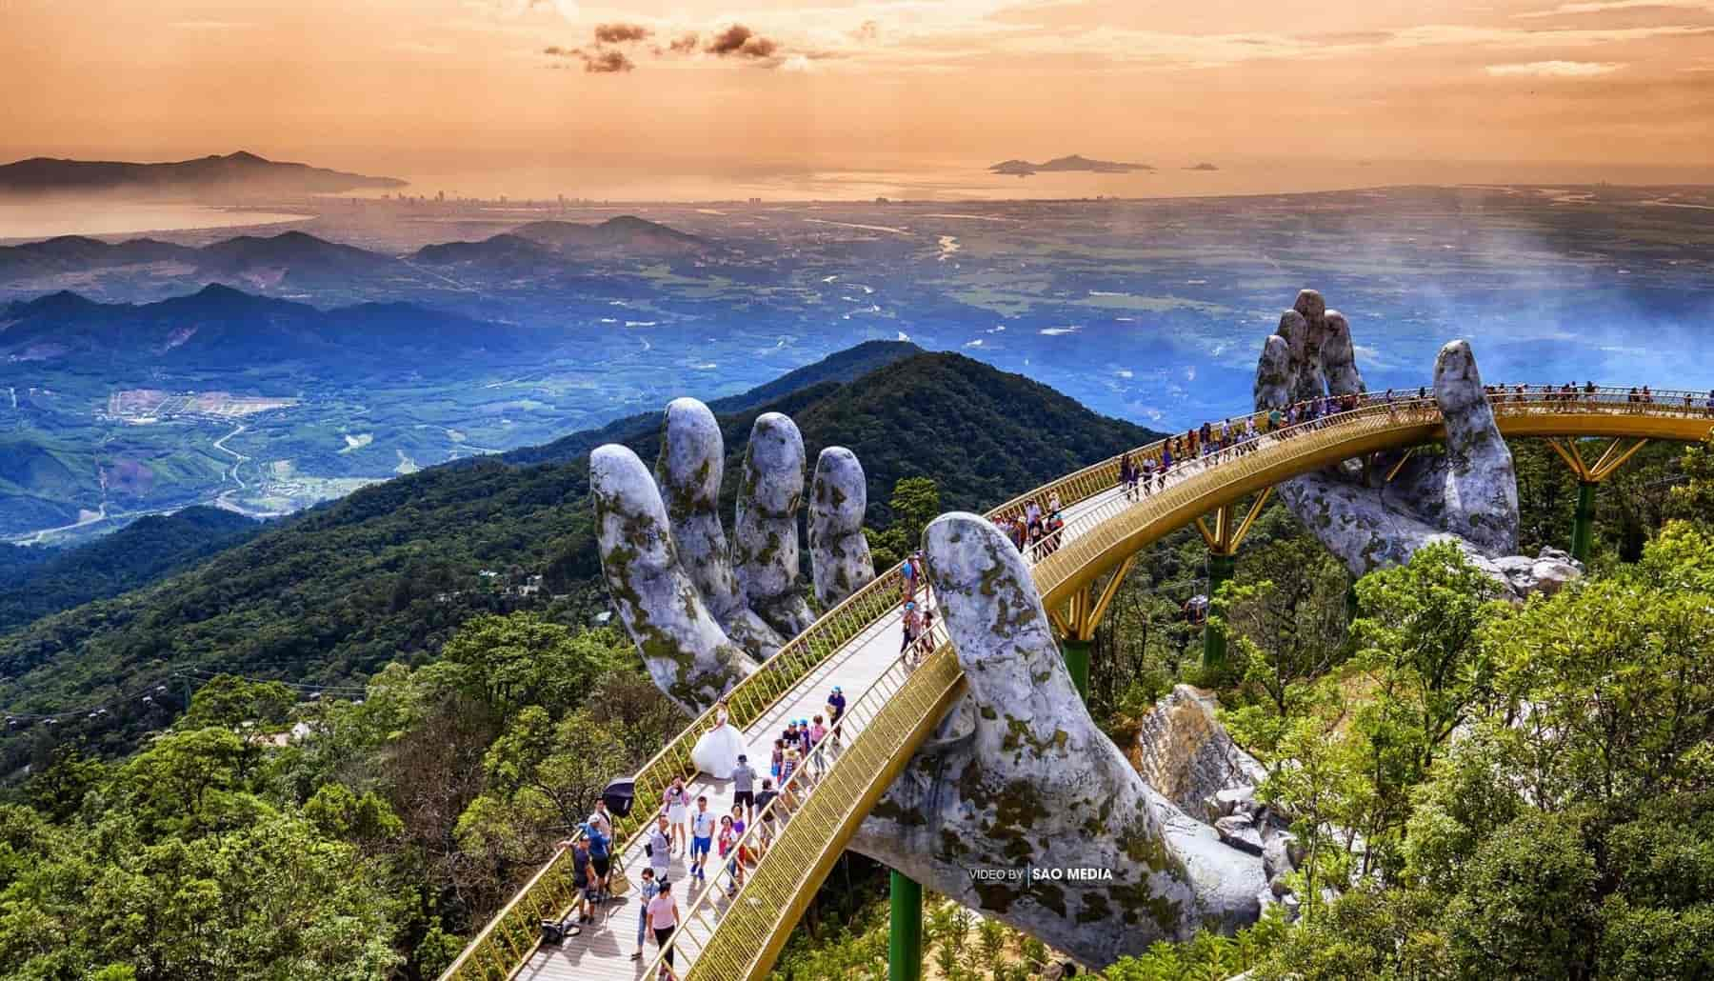Vietnam Tour from Nepal
Infamous for Vietnam War, a county torn apart by the War. Vietnam has come a long way dramatically unifying peace and prosperity in just a couple of decades, now its most beautiful country located in Southeast Asia. Janaki Darshan offers Vietnam tour from Nepal, a country that has variety of rich history and culture, breathtaking beaches and islands, temples, and pagodas, World Heritage sites, and natural beauty at its prime with series of mountains. Vietnam has been satisfying its global visitors in every imaginable way and has risen up as one of the spectacular traveling destinations. Travelers around the worlds are attracted by the overwhelming natural beauty sights which are not easily available to see at one place. And Contains many historic attractions and old temples.

Day 1: Welcome to Hanoi
Arrive in Hanoi via flight. Upon arrival in Hanoi and clearing all the immigration and customs process, you will be welcomed by our representative and privately transferred to the hotel for check-in.
Depending on your flight schedule, the rest of the day will be arranged. Arrival to the capital city of Vietnam before evening will allow you to enjoy optional activities comprising of in-depth walking tour of Hanoi Old Quarter exploring hundreds of years’ old maze of streets and architecture, overview drive of Hanoi capital admiring the city for its sophistication, and taking part in water puppet show – one of the mind-soothing attractions of Hanoi.
Ending the day, you will be spending an overnight stay at the hotel in Hanoi following a delightful welcome dinner
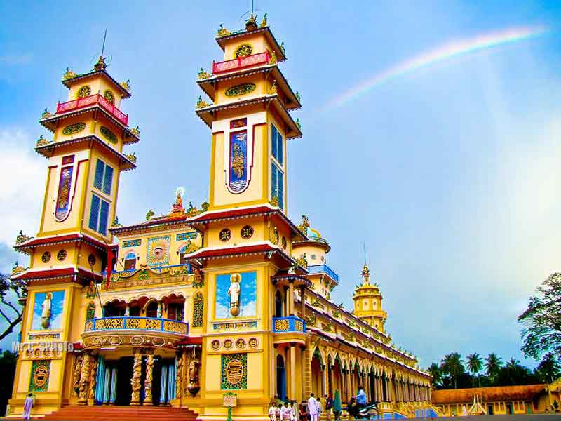

Day 2: An in -depth tour of Hanoi city
Greet the beautiful morning in this beautiful country and start your day with a warm and fresh breakfast at the hotel.
After finishing up on a pleasant breakfast, you will be picked up by our representative to start an in-depth tour of Hanoi city. This delightful city with rich culture and centuries old temples and other architectures being its main attractions has been popular amongst the travelers across the world for years. Experience serenity around Tran Quoc Pagoda & West Lake –one of the most ancient Buddhist temples in Hanoi standing on a small island. Get to learn Vietnam’s most influential history in the Ho Chi Minh Mausoleum – Ba Dinh Square – a must-see place, formerly residence of Vietnamese independence leader, Ho Chi Minh. Visit One Pillar Pagoda – an elegant historic Buddhist temple; Temple of Literature – one of Hanoi’s most picturesque tourist attractions studded with beautiful gardens, peaceful environment, ponds, and impeccable pagodas and statues; and the Hoan Kiem Lake – a quiet and peaceful tranquil lake surrounding the beautiful Ngoc Son Temple. Explore Hanoi Old Quarter by electric car and indulge in French-colonial architecture, temples and pagodas, historic galleries, rich food culture, and much more. Take time for shopping and exploring the city as per your delight at the end of the day.
Ending the day filled with gorgeous sightseeing, you will be escorted to your hotel for a warm delicious dinner and an overnight stay.
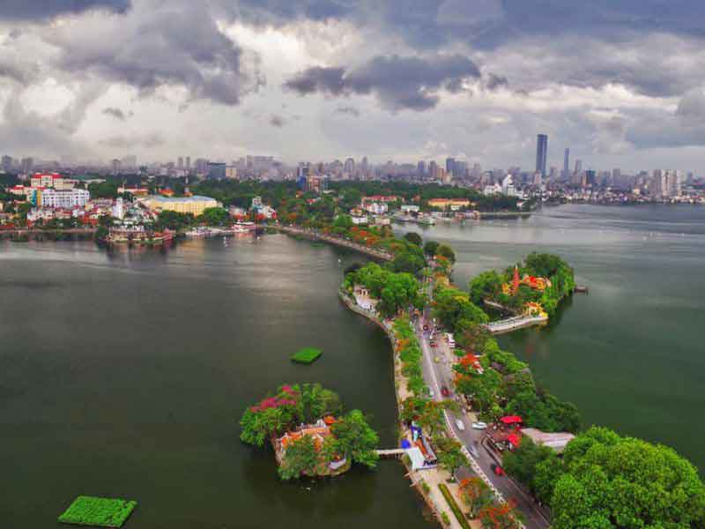

Day 3: Hanoi to Ninh Binh
Following a fresh healthy breakfast at the hotel, leaving behind Hanoi, today we travel to Ninh Binh – a small city in Red River Delta.
After finishing up breakfast, you will be picked up by our representative and escorted to your vehicle to visit Ninh Binh. Drive alongside the road of Vietnam losing yourself to the magical picture-perfect views of nature. Upon arriving Ninh Binh, visit Trang An – an UNESCO World Heritage site most popular for its boat cave tour and a spectacular site of limestone landscape. Explore most amazing architectural ensemble in Bai Dinh Pagoda – a spiritual complex of ancient Buddhist temples surrounded by nature. Climb up to discover the highest viewpoint in Ninh Binh, the Mua peak, for the most spectacular panorama view of Ngo Dong River in Tam Coc. An absolute must-do in Ninh Binh, the Mua peak provides sights of out of the world landscape, limestone cliffs, rice paddies, and much more.
Ending the day of discovering the beauty of Vietnam, you will be dropped off by our representative at the hotel in Ninh Binh for a delicious dinner and an overnight stay.
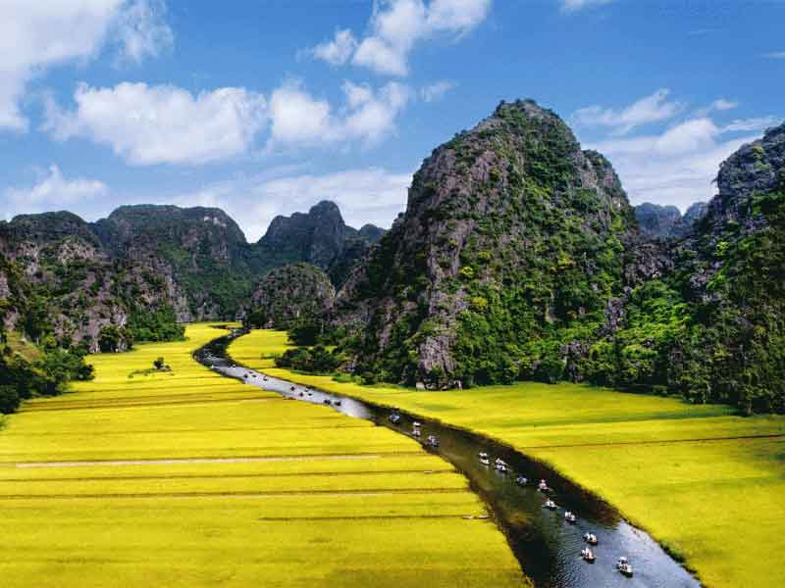

Day 4: Cruise on Ha long bay-overnight on Bay Cruise
Greet the sun in the fresh morning with a delightful breakfast at the hotel and get ready to travel to the beautiful wonder of nature, Ha Long bay.
After breakfast, you will be picked up by our representative to take a four-hour drive towards Ha Long Bay. Upon arriving Ha Long Bay, hop on Bhaya Cruise for the finest cruising experience in Ha Long Bay. Cruise amongst the natural wonder of Ha Long Bay alongside the series of limestone mountains and the bay’s magnificent scenery. Enjoy spectacular service on the boat filling up on seafood lunch and relaxing on the deck admiring the breathtaking views. Discover the secret caves, kayaking, and fishing village on the bay and experience the awesomeness of fantastic cooking class.
Enjoy the wonderful ambience and incredible dinner at the end of the fantastic day and stay overnight on board the Bhaya Cruise.
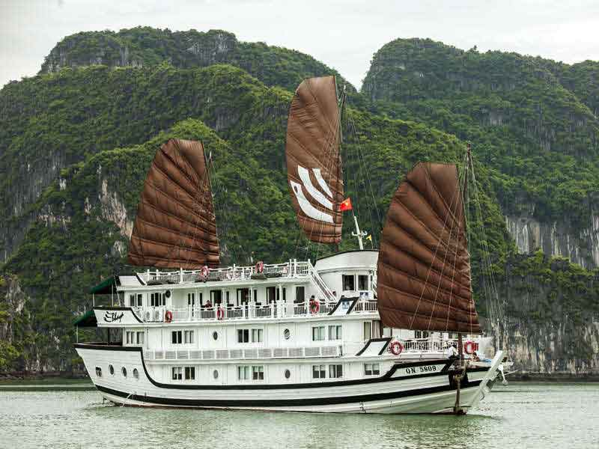

Day 5: Ha long bay to Hanoi Departure
Rise up early for the peaceful spiritual side of Vietnam. A warm fresh morning on the cruise is nothing less than magical.
Upon waking up, you will be advised to go on the top deck of the cruise for Tai Chi – a route of martial arts containing a series of slow flowing body movements that emphasizes on concentration, relaxation, and meditation. A light breakfast later, you will disembark the cruise for a short exploration of the cave close by the bay. Upon embarking the cruise again after the mystical cave exploration, you will be advised to pack up your belongings for the final disembarkation following a pleasant brunch cruising back to the land. Upon disembarkation and on your drive towards the airport (as per time allows), you will be visiting Ba Vang Pagoda – a centuries-old historic Buddhist temple for a Zenful experience and a photo or two of its scenic beauty.
Ending the memorable Vietnam tour, after a quick stop en route to the airport for coffee and snacks, you will be assisted by our representative to board your flight home to your loved one.
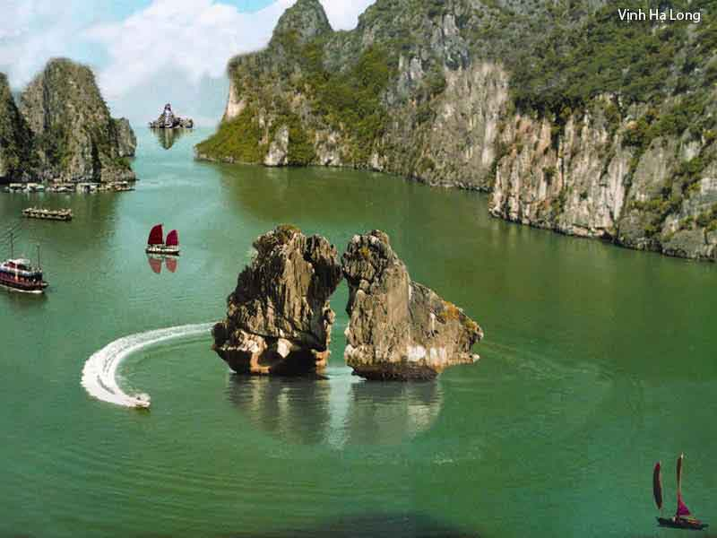

Inclusions
- Transportation in private air-conditioned vehicle with driver
- Accommodation in triple sharing room
- Meal as mentioned in the program: B= Breakfast; L= Lunch; D= Dinner
- Entrance fee to indicated sights
- English speaking guide
- All International Flight

Exclusions
- Early or late check-in/out
- Other meals, tips and drinks
- International airport tax
- Single room supplements, peak season surcharges and personal expenses
- Travel insurance, visas, any optional additional tours or activities during free time
- Early check in/late check- out at your hotel

