Best of Vietnam & Cambodia

Vietnam and Cambodia Holidays from Nepal
Join Janaki Darshan as we explore the incredible Vietnam and Cambodia holidays from Nepal to all travelers and discover why collectively these two nations have countless World Heritage sites amongst them. With a variety of rich history and culture, breathtaking islets and islands, ancient ruins and monuments, grand temples(Ta Prohm) and pagodas, and natural beauty at its finest, Vietnam and Cambodia are today one of the most spectacular, heavenly, and mystical traveling destinations. This holiday, let’s appreciate the unconventionally amazing Vietnam’s natural beauty and let’s try to uncover the mysteries that Cambodia has put forth the world for so many years.

Day 1: Welcome to Hanoi
Arrive in beautiful Hanoi, the capital city of Vietnam, via flight.
Upon arrival at the airport and clearing all the immigration and customs process, you will be welcomed by our representative and privately transferred to your designated hotel for check-in. Depending on your flight schedule and as the time permits, you are scheduled for a fantastic welcome dinner comprising delicious Vietnamese traditional dishes at a traditional local restaurant in Hanoi. Upon enjoying the dinner at the fullest, you will be dropped off at your hotel in Hanoi for a comfortable overnight stay.

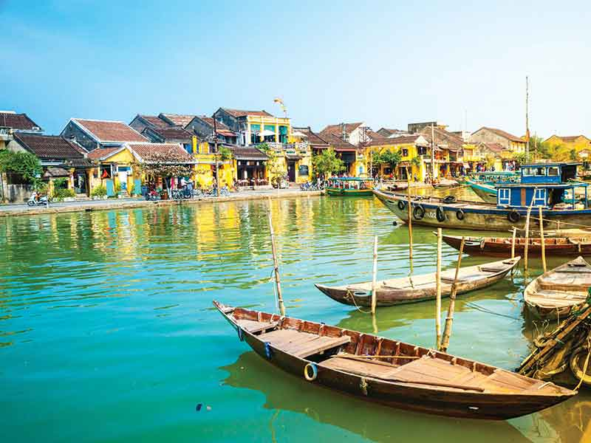

Day 2: Full day Hanoi city tour
Greet the beautiful morning in this beautiful country and start your day with a warm and fresh breakfast at the hotel.
After breakfast, you will be picked up by the tour representative to proceed towards Ho Chi Minh Complex. Upon arrival, learn about Vietnam’s most influential history in the Ho Chi Minh Mausoleum – a must-see place, formerly residence of Vietnamese independence leader, Ho Chi Minh. Visit The Presidential Palace, the Ho Chi Minh museum, and one pillar pagoda – an elegant historic Buddhist temple, while you are here. Soon after, proceed towards Temple of Literature and discover one of Hanoi’s most picturesque tourist attractions studded with beautiful gardens, peaceful environment, ponds, and impeccable pagodas and statues. Later in the afternoon, take a tour of the Museum of Ethnology and get an insight on Vietnam’s 54 officially recognized ethnic groups. Following museum tour, get on the streets of Vietnam and roam around the city in a car observing lifestyles of Hanoian people as well as different aspects of this beautiful city. After that, arrive at Hanoi Old Quarter and explore the Old Quarter indulging the French-colonial architecture, temples and pagodas, historic galleries, rich food culture, and much more. Take time for some shopping in this bustling area of narrow streets and alleyways. At the end of the day, you will be experiencing one of the mind-soothing attractions of Hanoi, the unique Water Puppet show. Enjoy Vietnamese traditional instruments and singing from live musicians.
Wrapping up the day, you will proceed towards your hotel for a cozy overnight stay after delighting upon the superb Vietnamese delicacies for dinner.
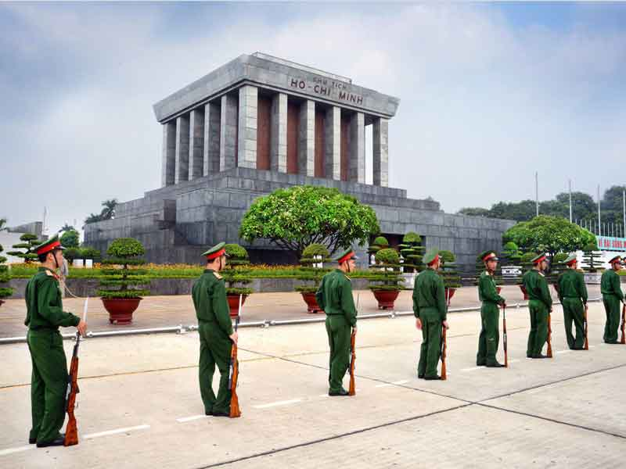

Day 3:Hanoi to Ha long Bay (cruise & overnight on oriental sails cruise
Greet the sun in the fresh morning with a delightful breakfast at the hotel and get ready to travel to the beautiful wonder of nature, Ha Long Bay.
After breakfast, you will be picked up by our representative to take an approximately four-hour drive towards Hong Gai Tourist Wharf. Upon arriving, hop on Oriental Sails Cruise for the finest cruising experience in Ha Long Bay. Cruise along the natural wonders alongside the series of limestone mountains and islands and the bay’s magnificent scenery as you savor a delectable lunch. After lunch, disembark and visit the fishing village along the bay and discover secret caves and extremely interesting daily lifestyle of villagers and fishermen. Hop on a rowing boat and take advantage of excellent photographic opportunities alongside the lagoon surrounded by mountains. Or, in lieu just go to the beach and have fun sunbaking, swimming, kayaking, playing volleyball, and enjoying all other fantastic water activities to delight yourself. Just before the sun starts to set in the horizon, embark the Oriental Sails Cruise and enjoy happy hour at the cruise bar and chill on the sun deck admiring the breathtaking views. Later, shake your inner cook taking part in cooking class with the cruise chef and have fun inventing your own delicacies.
End your day delving upon a mouth-watering seafood dinner and night squid fishing before you turn up the bed for a comfy overnight stay on board.
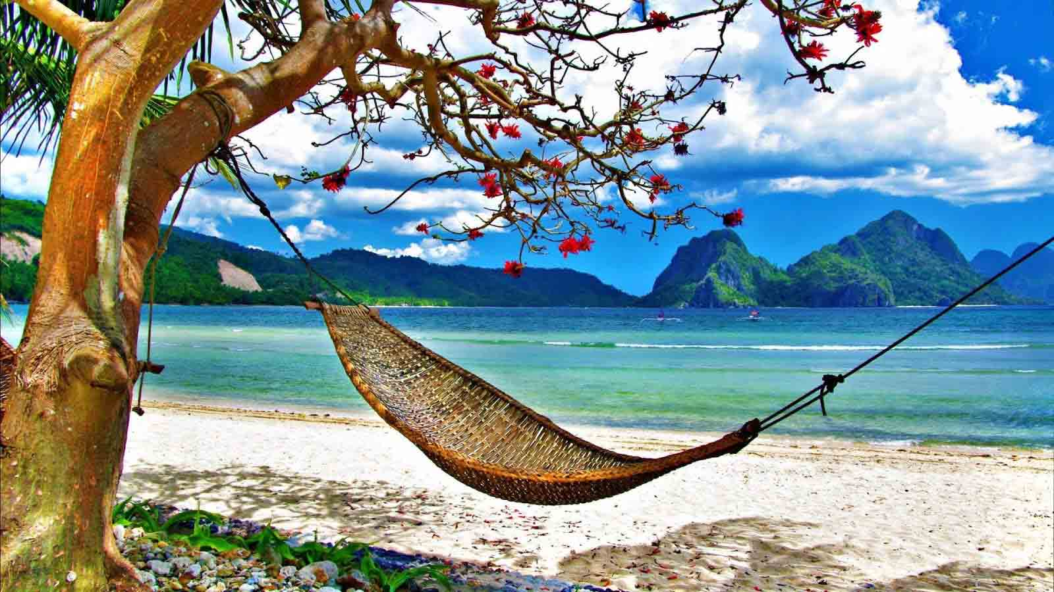

Day 4: Ha long to Danang/Hoi An
Rise up early for the peaceful spiritual side of Vietnam. A warm fresh morning on the cruise is nothing less than magical.
Upon waking up, you will be advised to go on the top deck of the cruise for Tai Chi – a route of martial arts containing a series of slow-flowing body movements that emphasizes on concentration, relaxation, and meditation. Catch the morning view of the horizon and a light breakfast later, you will disembark the cruise for exploration of Thien Canh Son Cave located in Bai Tu Long Bay. Upon embarking the cruise again after the mystical cave exploration, you will be advised to pack up your belongings for the final disembarkation off Oriental Sails Cruise following a pleasant brunch cruising back to the land. Off boarding the cruise, the tour representative will be driving you towards the airport to catch a short flight to Danang. You will be greeted by yet another tour representative upon your arrival at Danang Airport and will be transferred to your designated hotel in Hoi An for check-in.
Get rested and relaxed after a pleasant meal and ready yourself for an overnight stay at the hotel in Hoi An.
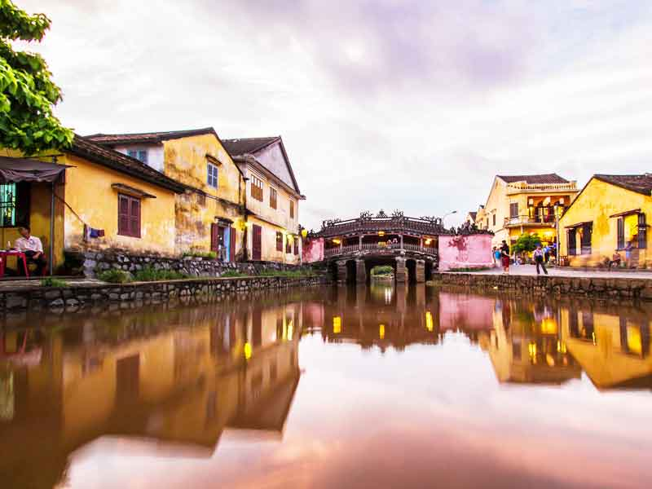

Day 5:Hoi An cycling Tour Plus Hoi An walking Tour
Make sure to fill up on hefty breakfast this morning as today you will be burning lots of those calories you have in store for so long.
After breakfast, you will be each provided bicycle for your cycling tour of this ancient coastal town, Hoi An (other means of transport if uncomfortable with bicycle). The tour begins as you peddle along the level ground to Thu Bon River. Discover interesting fishing village as you cycle along the country lanes and learn about quiet and calm daily local lifestyle of farmers and fishermen and observe how they work through their fields to provide for their family. Ride along making your way through mesmerizing locale, palm forests, bridges, rice paddies, ponds, and rivers. Give you legs a little room to breathe and visit a local family at Cam Thanh Village as you learn and be amazed by their way of living. While here, utilize your time learning and riding the quite unique, but efficient at the same time, traditional basket boat going afar the waters and spend your time catching fishes and purple crabs in the canal and add another thing in your lifetime memory to never forget about. Bidding goodbye, continue peddling and head for Tra Que Organic Vegetable Village, a fantastic venue to see a large variety of vegetables produced traditionally and organically by the local community. Observe and enjoy the company of local families as you lunch and learn their cooking styles and lifestyle. After the unbelievable authentic experience, head back to your hotel in Hoi An and ready yourself for a walking tour of Hoi An Old Quarter. Explore the exceptionally well-preserved Japanese port of trade. By all means, Hoi An old Quarter is a living museum comprising attractions such as rare wooden architectures, pottery museum, centuries-old houses, Japanese Covered Bridges, Chua Ong Pagoda, vibrant markets, and lots more. Walk through the tranquility of Old Quarter and catch a glimpse of Vietnamese history.
End the adventurous day just relaxing on the beach or shopping away as you delight, and then head back to the hotel for an overnight stay after thoroughly enjoying your dinner.
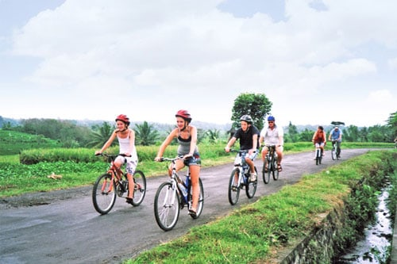

Day 6:Hoi An to Saigon (Saigon city tour)
Enjoy a freshly prepared breakfast at the hotel in the morning and start packing up your belongings to leave Hoi An for Saigon.
After breakfast, the tour representative will escort you to the airport to catch a short flight to Saigon. On arriving Saigon Airport, the driver will greet you and will transfer you to your designated hotel for check-in purposes. Freshen up and rest for a while before starting your half-day tour of Saigon, the largest city in Vietnam, commonly known as Ho Chi Minh City. After resting up, as scheduled, proceed for a sightseeing tour of this historically significant city, Saigon. Witness the infamous now-demolished American Embassy reminiscing the wartime. Visit the iconic Reunification Palace or popularly known as Independence Palace, wartime command centre of Vietnam and discover interesting areas such as war command room, communication center, and series of connected underground tunnels. Later pass through series of French colonial structures that Ho Chi Minh City is widely known for and get awe-inspired by the beauty and abundance of impeccable architecture these structures show off. As the last destination for the day, make your way to War Remnant Museum. While here, learn about the degree and horror of damage that a war can do. Try and take a feel of victims of the war and US atrocities through well-illustrated photographs and see war artefacts such as guns and artilleries used in the war, infantry weapons, armored vehicles, choppers, planes, tanks, and all kind of war spoils. Leaving all these behind, later in the day, proceed towards Ben Thanh Market, one of the largest marketplaces in Saigon and shop away strolling around the bustling streets.
As the daylight dimmers, head to the hotel in Saigon for a nice and comfortable overnight stay after dining on authentic delicacies that Vietnam has to offer.
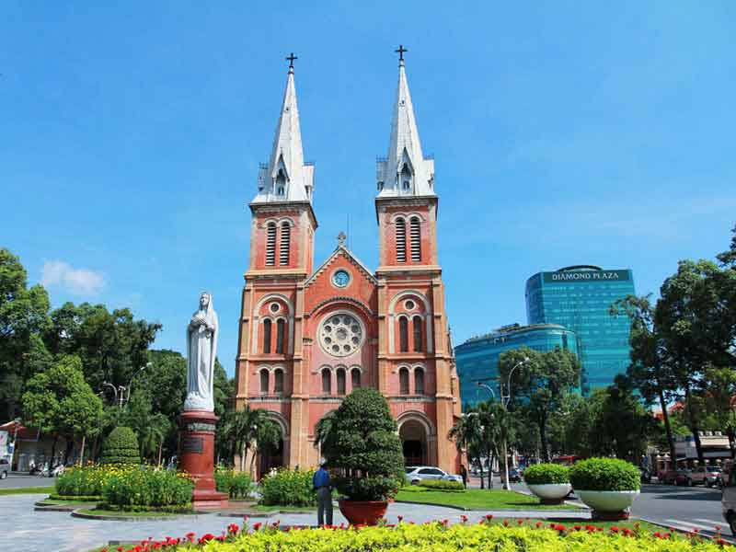

Day 7: Saigon to Ben Tre Province (Flight to siem Reap)
Freshen up early morning and have your breakfast at the hotel in Saigon and get ready for the tour of this beautiful city of Saigon.
After breakfast, start the morning trip as you drive through greenery and scenic route to arrive at natural getaway, My Tho city. Once in My Tho city, hop on to a motorized boat and catch magnificent glimpses of various spectacular islets, stilt houses, fishing ports, and boat-building workshops as you make you way through Tien River to the Qui (Tortoise islet). Capturing the picture-perfect nature’s wonders, the boat will lead you through Bao Dinh canal to enter Ben Tre province, the coconut county housing a wide variety of flora and fauna and waterways and canals shadowed by water coconut tree. Rowing on a row boat in the canal is so magical you would never want to leave the place. Get a taste of coconut candy and the famous honey tea while you are here. Grab a lunch amongst the amazing beauty of nature at orchard garden. Talk a walk on the island after relishing upon the delicious lunch and visit the village observing the beauty and simplicity of the natives while they carry on with their daily chores in a tranquil environment on the lap of Mother Nature. Visit the vast fruit garden traditionally growing every kind of tropical fruits and enjoy the juiciness right from the tree. Heavy heartedly leaving Ben Tre behind, hop on to the motor boat and head for Mt Tho city. Once at the hotel in Saigon, grab you backpacks and transfer to the airport to catch a flight to Siem Reap, a prime tourist hub of Cambodia.
Upon arrival to Siem Reap, you will be welcomed by the tour representative who will drive you to your designated hotel in Siem Reap for a comfy overnight stay.
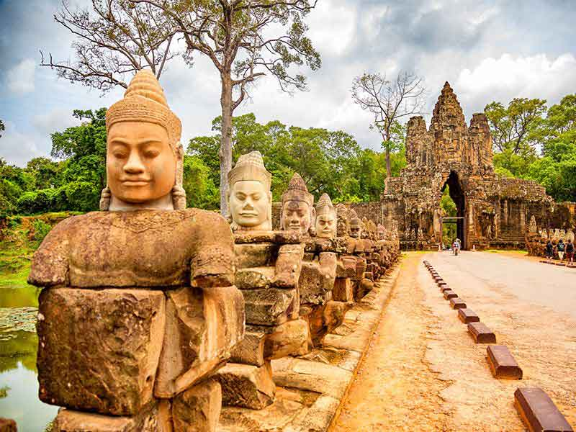

Day 8: Angkor Wat and Angkor Temples Complex Tour
Wake up this delightful morning and savor a fresh breakfast at the hotel and ready yourself for a full day tour of Siem Reap, literally the resort town of Cambodia.
After breakfast, accompanied by the tour representative proceed towards Ta Prohm, a mystical ruin mockingly known as the Tomb Raider Temple. Surrounded by dense jungle, Ta Prohm is so ancient that till this date attempts at discovering the mysteriousness of the temple and surrounding area have been in vain. Witness the most unbelievable sights while you try and solve the mystery. Soon later, make your way towards the famous Angkor Wat, a stunning grand temple complex believed to be built in or around 12th century. Explore the mammoth complex dotted with extraordinary architecture, innumerable sculpture and artistic decorations, statues, monuments, and ancient temples. Then after, visit antique capital of Angkor Thom. Explore and get awestruck by this World Heritage site especially known for the Bayon Temple containing countless stone temples along with five monumental gates studded with various statues of gods and demons as well as elephant trunks, illustration depicting churning of the ocean of milk, and lots more.
Later in the evening, enjoy a buffet dinner and enjoy Khmer Traditional Dance Show at local restaurant before arriving at the hotel for a nice and quiet overnight stay in Siem Reap.
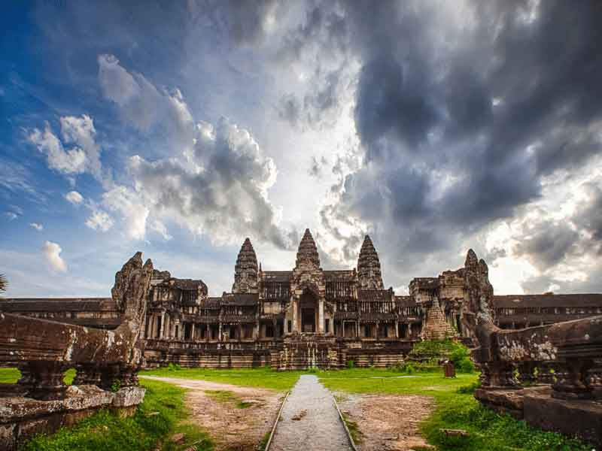

Day 9: Departure
After enjoying a nice breakfast at the hotel, manage your time in accordance with the flight schedule. Check out of the hotel and transfer to the airport for your return flight home. Return home with wonderful memories of your stupendous tour with us.
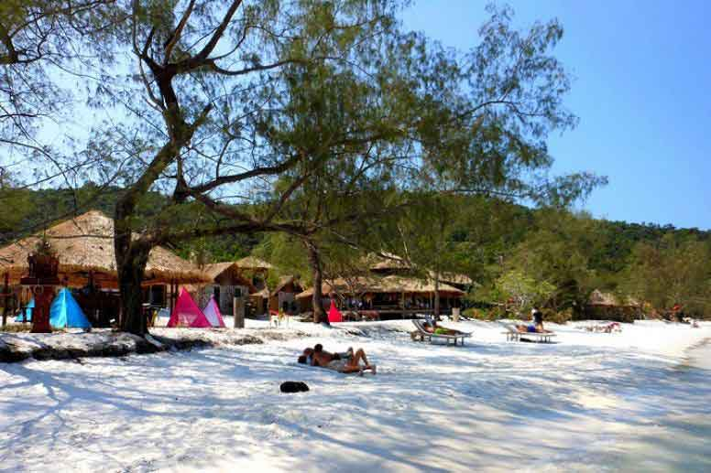

Inclusions
- Private tour for 02 persons only
- Accommodation at the best hotels 3***star as indicated in the program (01 double/ twin room upon your request)
- Meals as indicated in program (B – breakfast, L – lunch, D – dinner)
- All air tickets (Vietnam Airline, economy class, tax & service charge
- included): * Hanoi – Hue
- Hoi An/ Danang – Ho Chi Minh City (Saigon)
- Ho Chi Minh City (Saigon) – Siem Reap
- A/C private car for transportation at places as indicated in program
- Cruise & Overnight on Oriental Sails Cruise in Halong Bay (01 A/C private cabin for 02 persons on cruise)
- Private boat to cruise in Hue, Hoi An and Mekong River at the places as indicated in the program
- All admission cost at places mentioned in itinerary
- English speaking tour guide
- All entrance fees
- All taxes
- Local mobile phone during the trip

Exclusions
- Other meals and drinks/ personal expenses are note noted in the program
- Insurances
NPR 1,90,700per person
- Sightseeing : Hanoi, Hanoi to Ha Long Bay (Cruise & Overnight on Oriental Sails Cruise), Danang/Hoi An, Hoi An Cycling Tour Plus Hoi An Walking Tour, Saigon, Ben Tre Province (Flight to Siem Reap) & Angkor Wat and Angkor Temples Complex
- Duration : 8 Nights and 9 Days
- Accomodations : 2 Nights at Hanoi, 1 Night at Ha Long Bay (Cruise & Overnight on Oriental Sails Cruise), 2 Nights at Hoi An , 1 Night at Saigon and 2 Nights at Ben Tre Province
- Group Size : 2 Person

