UK Scotland tour from Nepal
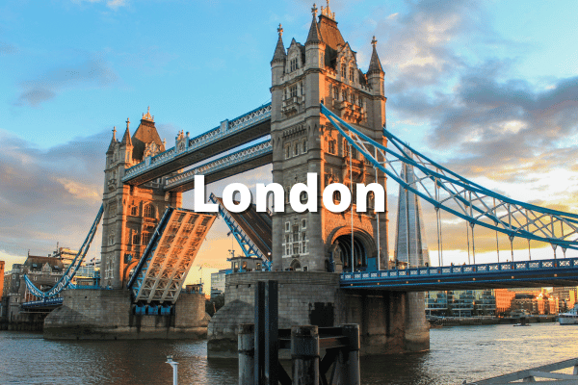This iconic kingdom is the place where traditions and history meet the technology and future. So, London is a land of Royalty and Majesty.
A traveler’s delight, United Kingdom has long been a hidden surprise for the vacationers. The main iconic landmarks are Buckingham Palace, mystical Stonehenge, and Big Ben in this UK tour. This place is shrouded with breathtakingly beautiful landscapes, Sceneries, and medieval wonders. It is because this land of knights and castles has been deservedly capturing audiences from around the globe. Besides this, you will love to know the history of UK. In the end, people who take UK trip from Nepal are more likely to revisit.
Janaki Darshan Tours & Travels is best to travel agency in Nepal for the trip to the UK Scotland tour from Nepal.

Tour Itinerary

Day 1 : Welcome to London
Arrive in London via flight. Upon arrival and after completing the customs and immigration formalities, you will be welcomed by our representative who will help you transfer from the airport to your hotel in London.
After checking in to the hotel – Hotel Central Park 3 or similar, the rest of the day is at leisure. Relax and take some time to stroll around a bit and feel the London air. After a scrumptious dinner, you will be spending a comfortable overnight stay at the hotel.
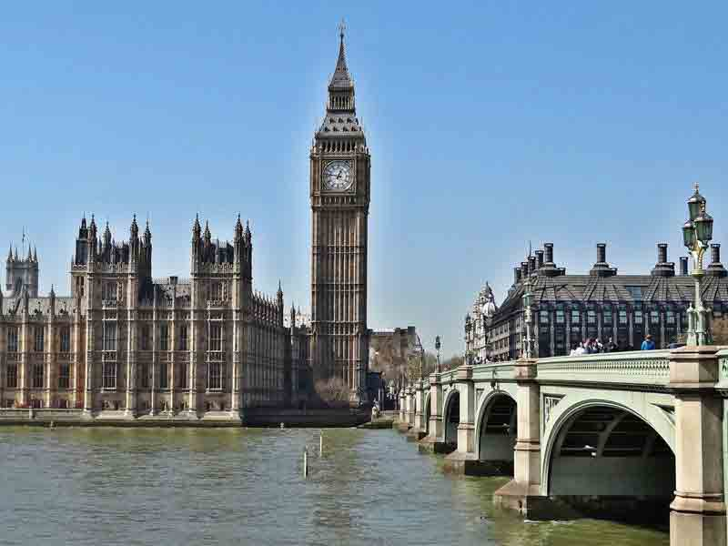Day 2 : London Sightseeing
Greet the morning sun with a nice and fresh breakfast at the Hotel. The London sightseeing tour begins today.
After finishing up breakfast, you will proceed for The Original Tour London Sightseeing. This hop-on hop-off sightseeing bus tour operator enables you a comprehensive London sightseeing. The spacious open-top double-decker bus will take you around the most recognizable landmarks on the face of the earth. Visit the top sights in London this day. Capture the amazing view of structures like London Eye – the Giant Ferris Wheel, Big Ben – the Great Bell, Westminster Abbey – one of the world’s greatest churches, Tower Bridge – an 18th century combined bascule and suspension bridge, and many more of other remarkable structures inside London.
Ending the delightful day of sightseeing, you will transfer back to your hotel for an overnight stay.
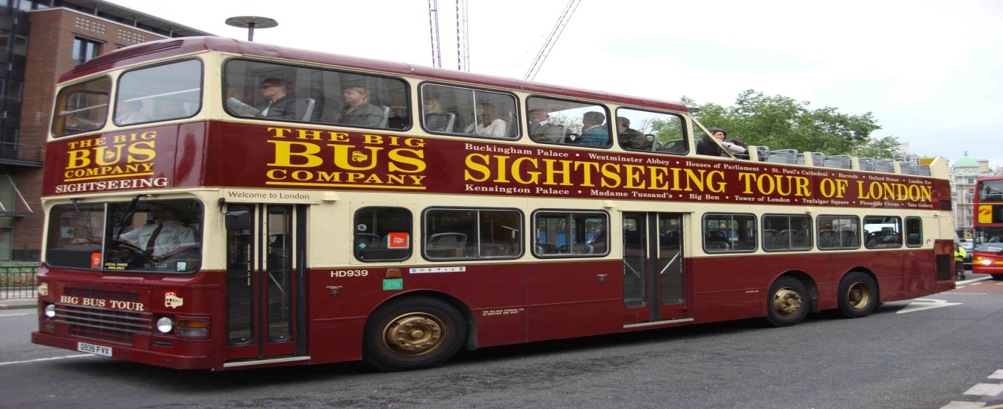

Day 3 : Tour of London
Start off another beautiful day in London with a nice refreshing breakfast at the hotel. Another sightseeing tour awaits you for your delight.
Soon after breakfast, you will proceed for the tour of Windsor Castle, Stonehenge, and City of Bath. The first stop for today is the lavish Windsor Castle, the oldest occupied castle in the world. Explore a 1000 years of royal history in the Queen’s favorite residence. Stroll around the State Apartments decorated with period treasures and priceless works of art by the likes of Rembrandt and Leonardo da Vinci. See the Royal Memorials as you walk through St George’s Chapel and be uplifted by its marvellousness. Proceed afterwards to the Stonehenge, one of the ancient sites in Britain. One of the most recognizable prehistoric monuments, the mystical Stonehenge has been a subject of curiosity for over 5000 years and counting. It’s now time for the last destination of the day, the City to Bath. A UNESCO Word Heritage site, Bath consists of more museums in a square mile than any other city. The Bath Abbey, the beautiful Roman architecture, Georgian architecture, and natural hot springs will leave anyone visiting awe-inspired.
After a day full of gorgeousness, you will be transferred back to your hotel for an overnight stay in London.
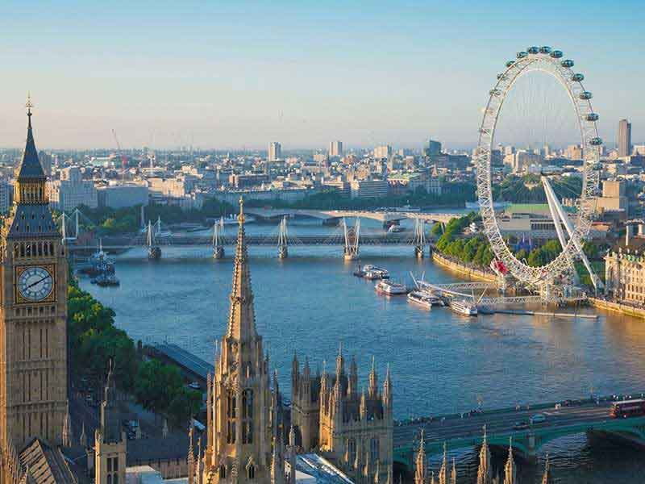Day 4 : London to Cardiff
Wake up for a hearty breakfast at the hotel and prepare to leave London and move on to Cardiff, the largest city and the capital of Wales.
After the breakfast, you will get ready and proceed to the London Paddington Train Station for departure to Cardiff. Following approximately two-hour journey in the train, you will be welcomed by our representative at the Cardiff. You will then be escorted to Holiday Inn Express Cardiff Bay or similar for check-in. The rest of the day is at leisure. Stroll around the city in the afternoon as per your delight. After a pleasing dinner, you will be spending overnight at the hotel.
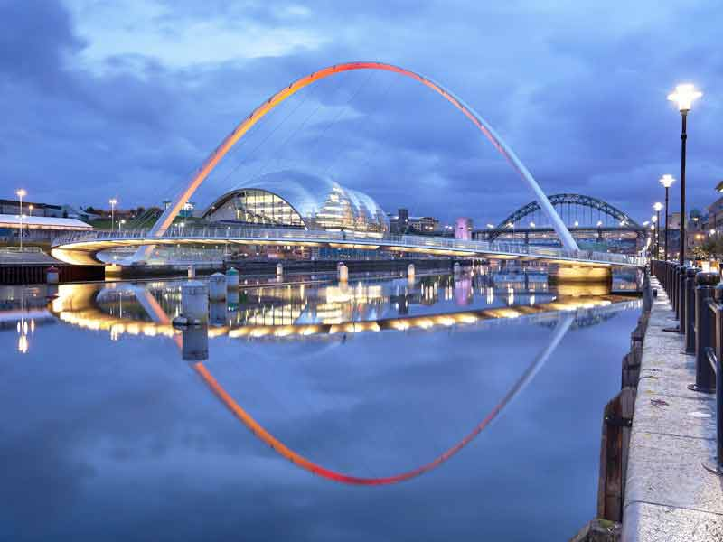Day 5 : Cardiff Sightseeing
Bore da! Today, you are up for a comprehensive tour of Cardiff – a great place for nature lovers and a fantastic place to visit.
After a delightful breakfast at the hotel, you will be transferring for Cardiff Hop-On Hop-Off Tour. The hop-on hop-off bus tour is one of the best ways of sightseeing in this fastest growing capital city of Europe. Explore the spectacular sites in Cardiff through the open-top double-decker bus. Capture the attractions that Cardiff has to offer. Visit and stop to capture the spectacular landmarks such as the Cardiff Castle – a gorgeous neo-Gothic castle comprising extensive Welsh history, the Millennium Stadium – home for Welsh rugby, Techniquest – a Welsh science and discovery centre that aims to inspire future scientists, and many more amazing sites.
After the ample time spent discovering the city, you will be heading to your hotel for an overnight stay in Cardiff.
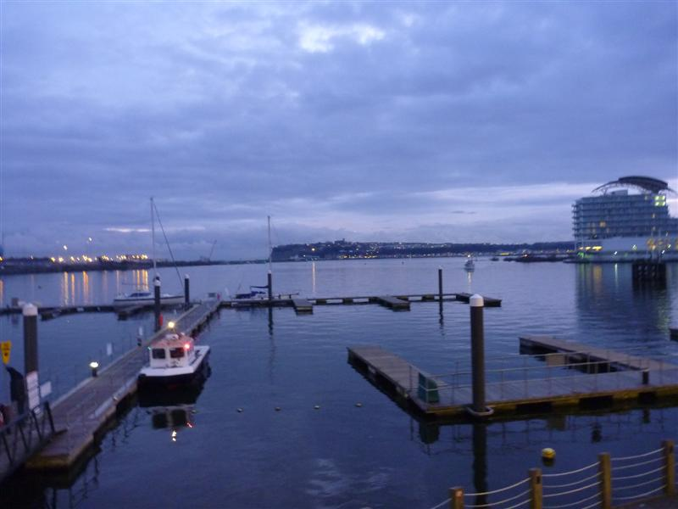

Day 6 : Cardiff to Edinburgh
Wake up for a pleasant breakfast at the hotel and prepare to leave Cardiff and move on to Edinburgh – the hilly capital city of Scotland.
After the breakfast, you will get ready and proceed to the Cardiff Central Train Station for departure to Edinburgh. Following approximately seven-hour journey via connecting train, you will be welcomed by our representative at the Edinburgh. You will then be escorted to Hotel Holiday Inn Express City Centre or similar for check-in. The rest of the day is at leisure. Stroll around the city in the afternoon as per your preference. After a pleasing dinner, you will be spending overnight at the hotel.
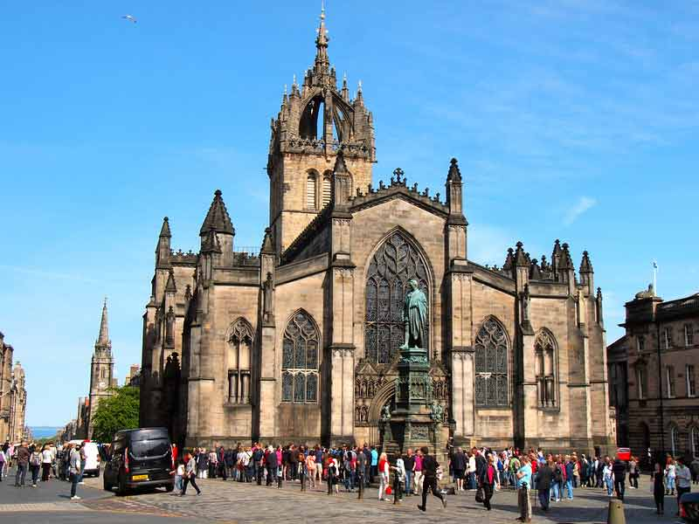Day 7 : Explore Edinburgh
Madainn Mhath! Today is the day for a comprehensive sightseeing of Edinburgh, the city built on Seven Hills.
After a pleasant breakfast at the hotel, you will be transferring to Hanover Street for the Hop-On Hop-Off Edinburgh Tour. Edinburgh is a city renowned for its panoramic marvel wrapped in the rocky hills. Explore this fantastic city through Hop-On Hop-Off Edinburgh bus tour service. Visit Edinburgh’s Old Town – sitting on an extinct volcano with centuries-old buildings and narrow alleys and the ever-elegant New Town – beautifully preserved town known for its historical and cultural significance and attractions. Visit the Grassmarket – a lively, vibrant, and picturesque marketplace with grand old buildings and structures; the impenetrable Castle Rock – a historic fortress; the Royal Mile – the street joining Edinburgh Castle and the Palace of Holyrood House; and much, much more.
After the fascination-filled tour spent discovering the city, you will be heading to your hotel for an overnight stay.
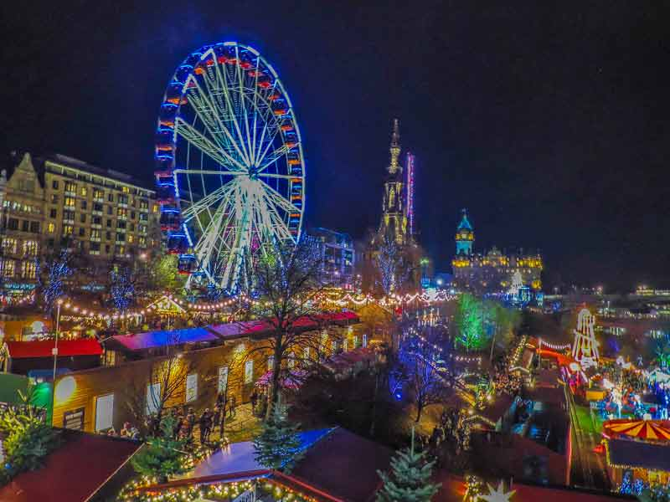

Day 8 : Tour of Edinburgh
Today is the day for Scotland’s most famous Original Loch Ness Tour to experience some of the finest scenery in Europe.
After a pleasing breakfast at the hotel, you will be escorted to the starting point of the tour. The Original Loch Ness Tour is the best way to squeeze out the finest of Scotland in a day. Treat yourself with the beautiful Scottish Highlands and Loch Ness – known for mythical monster “Nessie”. Explore Urquhart Castle – one of Scotland’s most historic and iconic castles. Leaving Edinburgh behind, the next stop of the tour is Stirling – a small vibrant Scottish city with a big history. Discover Rob Roy Country – home for Scottish folk hero, Rob Roy MacGregor; the Rannoch Moor – a 50-square-mile wilderness; and the Weeping Glen – Glen Coe – one of the most spectacular places in Scotland. The next stop for this tour will be the Town of Fort William, known for its famous scenic journey. Visit Spean Bridge and make you way to the Great Glen, a 62-mile long straight glen and experience the scenic beauty of the lochs, sparkling rivers, soaring mountains, and wild moorlands.
After a while day of enticing tour, you will be transferred to Edinburgh of an overnight stay at your hotel.
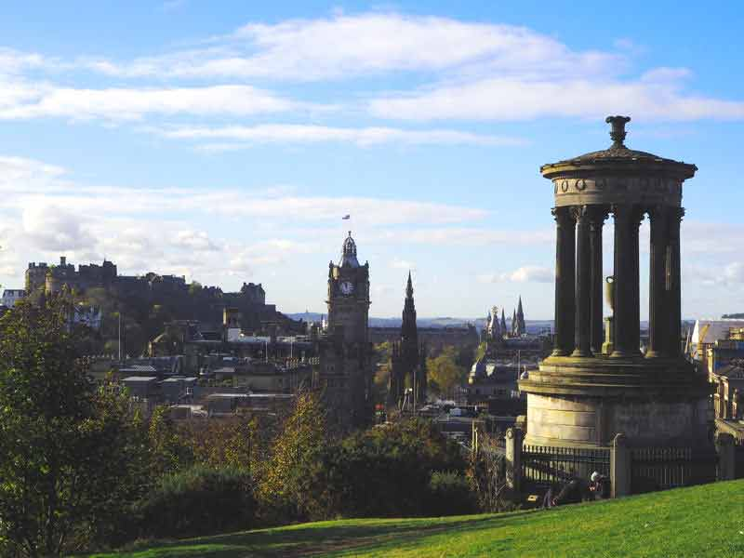

Day 9 : Edinburgh
Greet the beautiful morning with a delightful breakfast at the hotel and get ready for today’s trip on our Highland Glens, Castles, and Whisky Tour.
After breakfast, we proceed to the Kingdom of Fife – a historic county of Scotland. The first stop of today’s tour will be the Dunfermline Abbey and Palace – home for the remains of a great Benedictine. Delight yourself with the abbey and palace studded with Romanesque architecture consisting of structures beyond comparison. We proceed then to the beautiful Glen Devon, Scotland’s one of the most picturesque glen as our next stop for the day. Passing Glen Devon, we will arrive at the Town of Crieff – home for Glenturret Malt Whiskey Distillery and best known as a holiday town. Get a tour of the distillery detailing malt whisky production and opportunity for a tasting. Soon after, we will venture into the Highlands through the scenic route of Sma Glen and StrathBraan and make a pleasant stop for pictures and whatnot to capture the glimpses of the magnificent picturesque villages of Dunkeld and Birnam at the banks of River Tay. After a leisurely stroll, we head for our last stop of the day in South Queensferry and make our way back to Edinburgh.
Following a long day of travelling from places to places, you will transfer to your hotel in Edinburgh for an overnight stay.
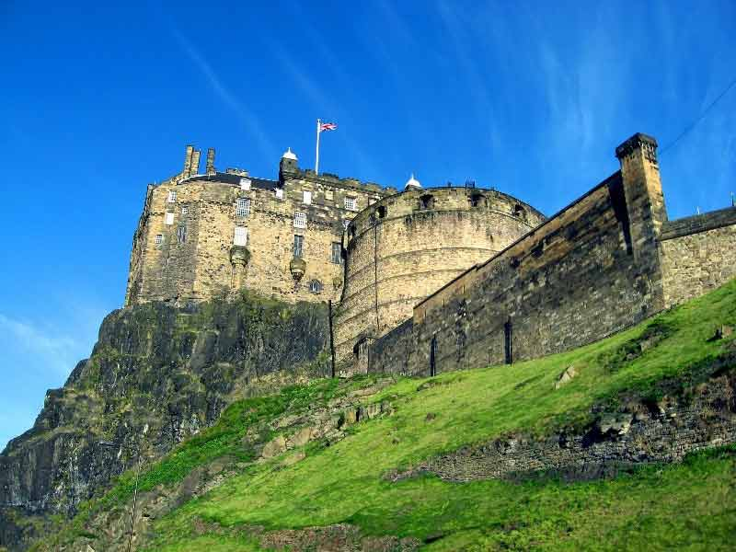Day 10 : Edinburgh to London
After a wholesome trip of UK, and Wales, today is the last day in Europe. After thoroughly enjoying your delightful breakfast, you will depart form your hotel and proceed to Edinburgh Train Station and catch your train to London. Upon arriving to London, you will be escorted to Heathrow Airport for your flight home to your loved ones with wonderful memories and adventures to share.
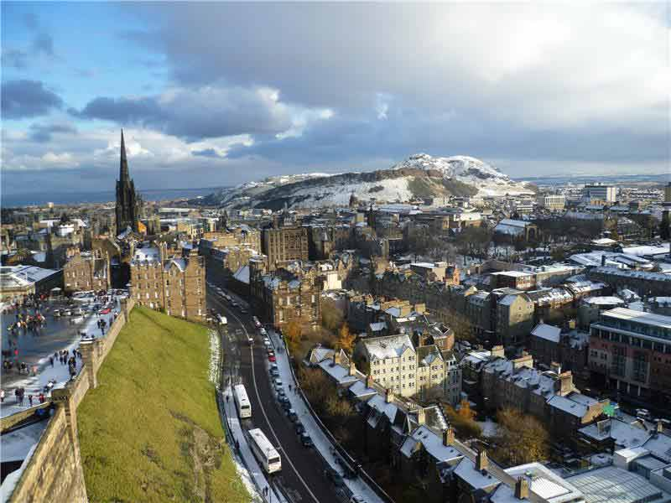

Inclusions
- 9 Nights Accommodation
- Daily Breakfast
- All Sightseeing Tours as mentioned in the below program on Seat in Coach basis
- Return Airport & Train Station transfers in all cities on Private basis
- 2nd Class Train Ticket: London – Cardiff – Edinburgh – London
- Visa Fees
- International Ticket
Tourist Visa Checklist
Original passport valid for at least Six months with minimum 2 blank pages. (face to face)
1) The passport should be issued less than 10 years ago.
2) Two photocopy of Passport photo page and address page of the applicant.
3) Photocopies of all valid US, U.K. and previous Schengen visas.
4) One application form & undertaking form with all columns filled in and 2 recent photographs in the size of 3.5 cms x 4.5 cms with white/light background.
All applicants should mention their mobile number on the visa application form.
5) Covering letter IN ORIGINAL signed by the applicant. For self- employed/businessman, going on tourist visa, covering letter preferably on company”s letterhead is required Copy of CONFIRMED prepaid hotel reservation OR sponsorship certificate (attestation d’accueil & photo id proof of invitee along with copy of the documents shown to the French town hall (electricity bill, taxes etc.)
6) IN ORIGINAL and Photocopy
7) Copy of ITINERARY prepared by the travel agency (for those going on tour)
8) Copy of income tax papers of last three years, last THREE month bank statement & updated, last 3 months salary slips
9) Photocopy of OVERSEAS medical insurance policy + REPATRIATION, evacuation cover (equivalent to 30,000 euros). Please carry your original insurance for verification at the time of submission of visa application form. **
10) Copy of air ticket or PNR (booking printout).
11) All applicants except first time traveler (traveling first time to a Schengen country) while applying for a French visa will be required to fill visa insurance undertaking form in addition to the visa application form.
12) For minor travelling alone the visa application must include an authorization from both his/her parents to travel alone. The authorization has to be certified by an entitled Indian/Nepalese authority and enclose copy of the parents’s identity.
If the minor is travelling with an adult other than his/her parents, this adult has to be legally
authorized by the minor’s parents to accompany him/her and take any measure that be needed in case of
illness, accident,etc.
If the minor is accompanied by only one of his/her parents, the other one should give his/her legal
authorization to let her/his child travelling with his/her spouse.
13) For any student under 18, applicants are requested by the French authorities to provide with either a photocopy of certificate from their school or university or any other document as a proof of their enrollment as a student or apprentice.
14) The photocopy of certificate from school or university or any other proof of professional or educative occupation is also requested whenever a young person over 18 is depending on his parents for his/her living expenses
15) Domestic help at the private service of a foreign national or a French national, accompanying his employer to France for a short stay needs to hold a working permit,like any foreigner going to work, full time or part time, in France.
Submission of a contract established between the employee and the employer in accordance with the
French Labour law, approved by the DDTEFP( Direction du travail, de l’emploiet de la formation
professionnelle) center of the employer’s place of vacation is compulsory for application for a visa.
16) NOC for school, college or Employers is required as a mandatory document. NOC from spouse with a signature proof if any one of the couple is traveling for tourism purpose.
17. Marriage certificate is mandatory for all the applicants who are married if their spouse name is not endorsed in the passport. If someone is not having a marriage certificate (newly married couple) then an affidavit declaring the applicants to be married with their photos pasted on the same should be produced.
18. All child within the age of 18years should provide a copy of birth certificate as a mandatory document.
19. All Documents must be submitted in A4 Size.

