Thailand, Malaysia, and Singapore
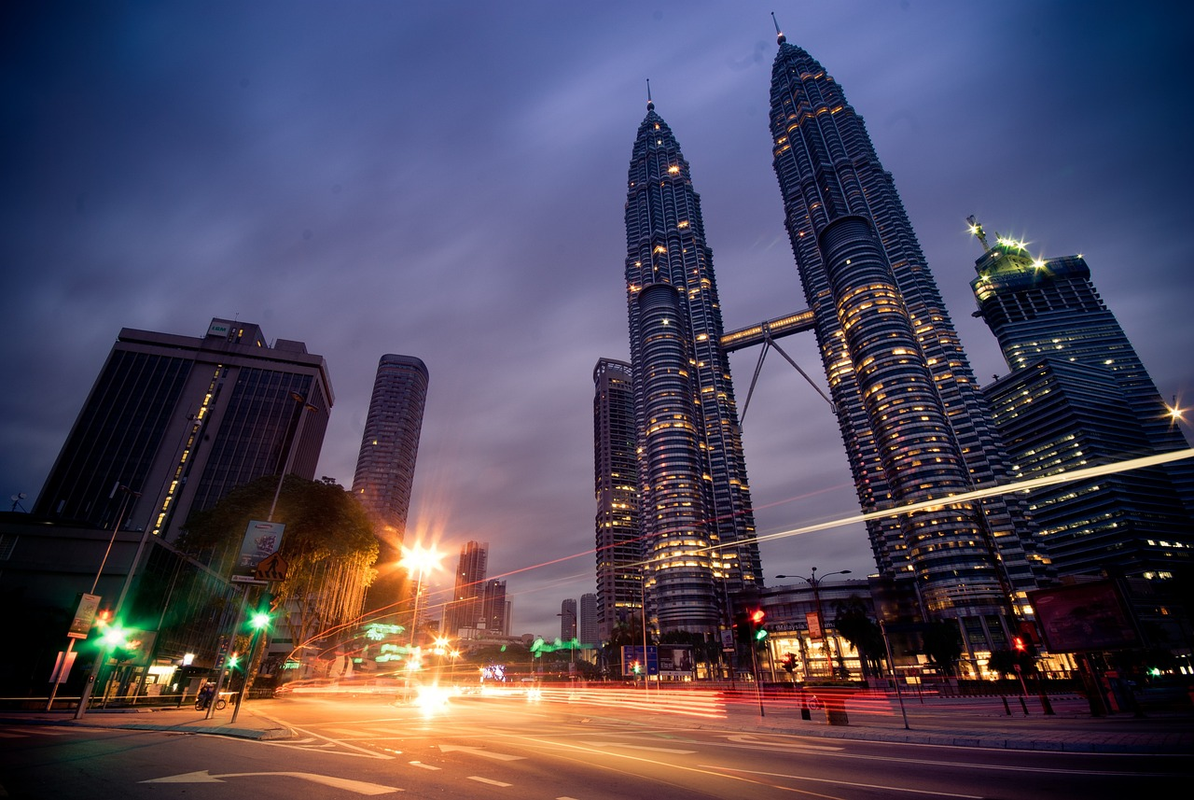
OVERVIEW ITINERARY INCLUSIONS / EXCLUSIONS FAQ
9 Nights / 10 Days  Food: B&B
Trip starts at: Kathmandu  Flights: Round trips
Accommodation: 3- Stars Trip Ends at: Kathmandu

Looking for a vacation that combines exotic adventure and modern luxury?
Look no further than this Combo Asia package featuring Thailand, Malaysia, and Singapore!
Begin your journey in Thailand, where you can explore ancient temples, pristine beaches, and bustling markets. Enjoy the delicious street food and indulge in a traditional Thai massage. Visit the stunning islands and take a dip in the crystal-clear waters.
Next, head to Singapore, the Lion City. From the futuristic Gardens by the Bay to the traditional neighborhoods of Chinatown and Little India, Singapore offers something for everyone. Shop at the world-renowned Orchard Road or relax at the luxurious Marina Bay Sands.
Finally, end your adventure in Malaysia, where you'll experience a melting pot of cultures, from the bustling streets of Kuala Lumpur to the serene Cameron Highlands. Discover the natural beauty of the Batu Caves or take a stroll through the UNESCO World Heritage Site of George Town. Taste the diverse culinary offerings of Malay, Chinese, and Indian cuisine.
Combo Asia is the perfect blend of adventure, culture, and luxury. With so much to see and do, don't miss out on this unforgettable experience. Book your trip today!

Outline Itinerary
Day 01: Arrive at Bangkok-Pattaya
Day 02: Pattaya Coral Island Tour with Lunch
Day 03: Pattaya to Bangkok
Day 04: Leisure for shopping and optional tour
Day 05: Flight to Singapore:
Day 06: City tour and Sentosa Island Tour
Day 07: Singapore to Kuala Lumpur
Day 08: Kualalumpur
Day 09: Sunway Lagoon Tour "The Best Wet & Dry Theme Park in Malaysia.
Day 10: Departure

Detail Itinerary

Day 01: Arrive at Bangkok-PattayaGreetings from Thailand! The most famous city in the Asia. Our

agent will be waiting for you at Suvarnabhumi International Airport when you arrive. After

that, you'll be driven to your accommodation in Pattaya. Check in at the hotel. You'll spend

the night at your Pattaya hotel.

Day 02: Pattaya Coral Island Tour with Lunch
Breakfast at the hotel. You will be picked up this morning to board a speedboat to Coral Island. Upon arrival, a glass bottom boat will present you to a breathtaking glimpse of the island's coral reef. You will be taken to the hotel after a delectable lunch. You can spend the remaining time of the day doing nothing but relaxing on the white sand beaches or swimming in the clear waters. Spend the night at the Pattaya hotel.

Day 03: Pattaya to Bangkok
Enjoy breakfast at the hotel before being picked up and driven to Pattaya. Take a half-day city and temple tour of Bangkok today to experience the city's beautiful culture. Over 26,000 temples or Wats exist in Thailand (local name). Spend the night at your Bangkok hotel.

Day 04: Leisure for shopping and optional tour
Enjoy breakfast at the hotel. The remainder of the day is reserved for shopping and optional activities.

Day 05: Flight to Singapore:
After breakfast you will be transfer to Airport to catch Singapore Flight. Upon Arrival at airport. Our Representative will pick up you and transfer to hotel. Overnight at hotel.

Day 06: City tour and Sentosa Island Tour
After breakfast, you will be picked up by our representative for a half-day city tour of Singapore. This tour shows you the city's various attractions. then move forward to the afternoon Sentosa Island trip. Sentosa Island is where we'll be spending the afternoon. From Mount Faber all the way across Keppel Harbour to Sentosa, we will travel via Singapore Cable Car (one-way). We will see a spectacular performance by the pink dolphins at the Dolphin Lagoon in the park. One of Asia's most well-known attractions, Underwater World Aquarium, will also be on our itinerary. Here, one can observe thousands of common and rare water species and take in a dynamic environment.

Day 07: Singapore to Kuala Lumpur
After breakfast, proceed to Kuala Lumpur and spend your free time afterwards. Overnight at the hotel.

Day 08: Kualalumpur
Enjoy a city tour of Kuala Lumpur after breakfast. Visit the National Monument, the Istana Negara (National Palace), the National Mosque, the Tudor-style Royal Selangor Club, the train station building with a Moorish influence, and Merdeka Square. The impressive Petronas twin towers will shortly be seen as we go. You will observe the diversity that makes this region "Truly Asia." Stay the night in the hotel.

Day 09: Sunway Lagoon Tour "The Best Wet & Dry Theme Park in Malaysia.
Sunway Lagoon, the best and biggest theme park in Malaysia, was wonderfully turned from the side of an old tin mine and quarry. It is a worldwide grade cascade of coasters, slides, and family attractions set amidst magnificently landscaped surroundings.

Day 10: Departure
After enjoying Breakfast, Checkout from the hotel and you will transfer at the airport with full of memories.

Services Included
- All Round Trip Air Fare
- Return Airport Transfer
- 3-Stars Hotels with BB Plan
- Visa Fee

Services Excluded
- Other Beverages throughout the tour.
- Personal expenses.
- Anything not mention in itinerary.

