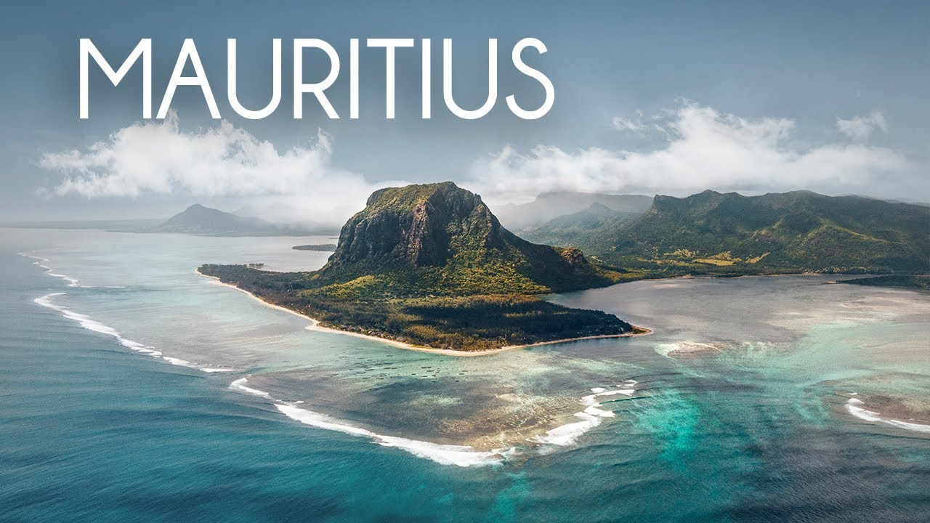Rightfully named paradise, Mauritius is as magical as it is mesmerizing. A spectacular island of white sandy beaches, tropical forests, mountains, immaculate coral reefs, and exotic wild as well as marine life, Mauritius is in every way a fantastic holiday location. Experience unbelievable picture-perfect sceneries, mountainous interiors, iconic sandy beaches, enormous marine world, and tantalizing natural environment with glistening waters and venture in water sports, wildlife observation, scuba diving, and much more in this land deemed a prototype of heaven. Most trending Outbound Package among Nepalese – Mauritius holiday packages from Nepal.

Tour Itinerary

Day 1 : Welcome to Mauritius
Arrive in Mauritius Airport via flight. Upon arrival, you will be greeted by our local representative who will assist you through the transfer to the hotel in Mauritius where you will check-in. Rest of the day is at leisure in this beautiful island nation known best for its beaches, majestic lagoons, and reefs.
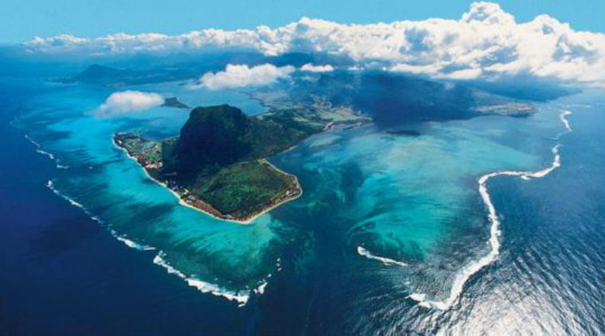

Day 2 : North Island Tour
Greet the beautiful day, with a pleasant delightful breakfast. As they say, Mauritius was made first and then heaven, the mornings in Mauritius are even better.
After breakfast, you will be picked up by our representative for a full-day tour of North Island. Proceed to explore the northern region of Mauritius. The North Island will fascinate you. Visit interesting and extraordinarily beautiful sights Mauritius has in store for your. Explore the Port Louis, the capital city of Mauritius and Place d’Armes with its French colonial buildings, and the exotic Caudan Waterfront, shopping complexes, and craft markets.
At the end of this fabulous day in this beautiful county, you will be dropped off by our representatives at your hotel where you will enjoy a nice heart-healthy dinner at the hotel. Overnight at Hotel in Mauritius.
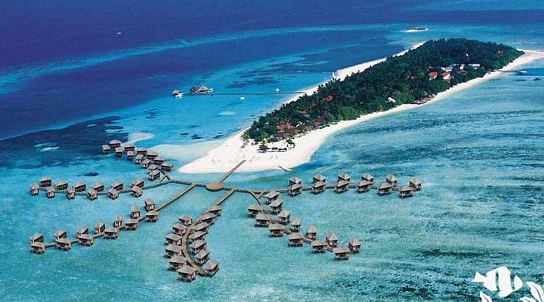

Day 3 : South Island Tour
Rise up for a nice and warm breakfast at the hotel and get pumped up as the gorgeous South Island tour is in store for today.
After breakfast early in the morning, our representative will escort you to your transportation for a full-day tour of South Island. The most beautiful landscapes of Mauritius are in South that awaits you today. Sandy beaches bordered by cliffs carved by waves and rocky shores will leave you in awe. Explore Trou Aux Cerfs – the famous extinct volcanic crater, Grand Bassin – most sacred extraordinary natural lake at the base of volcanic crater and a pilgrimage place for Hindus. Visit Chamarel, the seven coloured earth known for its cool breezes with its vibrant hues and waterfalls, a sight to remember.
Ending the majestic day, you will be dropped off by our representatives at your hotel in Mauritius for a delightful dinner and a cozy and comfortable overnight stay.
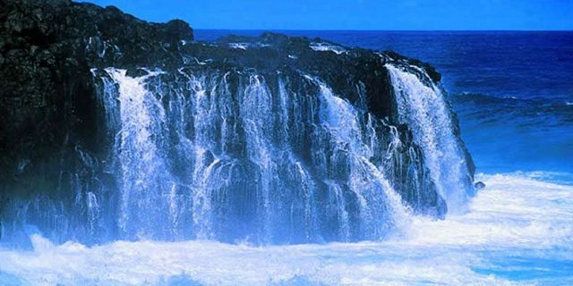

Day 4 : Departure from Mauritius
Last day of your marvelous journey. After enjoying a nice breakfast at the hotel, manage your time in accordance with the flight schedule, go for some last-minute shopping, and get busy packing up your belongings. Check out of the hotel and transfer to the airport for your return flight home. Return home with wonderful memories of your stupendous tour with us.
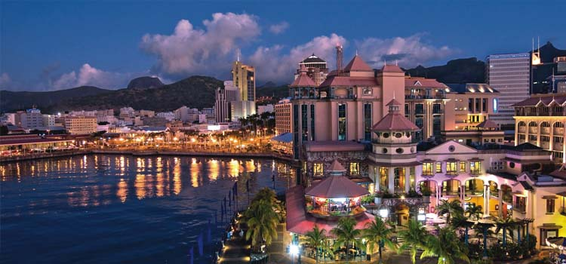

Inclusions
- Airport Pick up and drop
- Round Trip Economy Class Airfare
- Accommodation for 3 nights in Mauritius
- Daily Buffet breakfast at the hotel
- North Island Tour
- South Island tour
- Tour Aux cerfs

Exclusions
- Meals other than those specified (if any)
- Tips, Laundry, telephone, optional excursions and other items of a personal nature
- There is no refund for unused services or hotel nights offered within a motor coach tour itinerary
- Cost of foreign exchange for personal use

