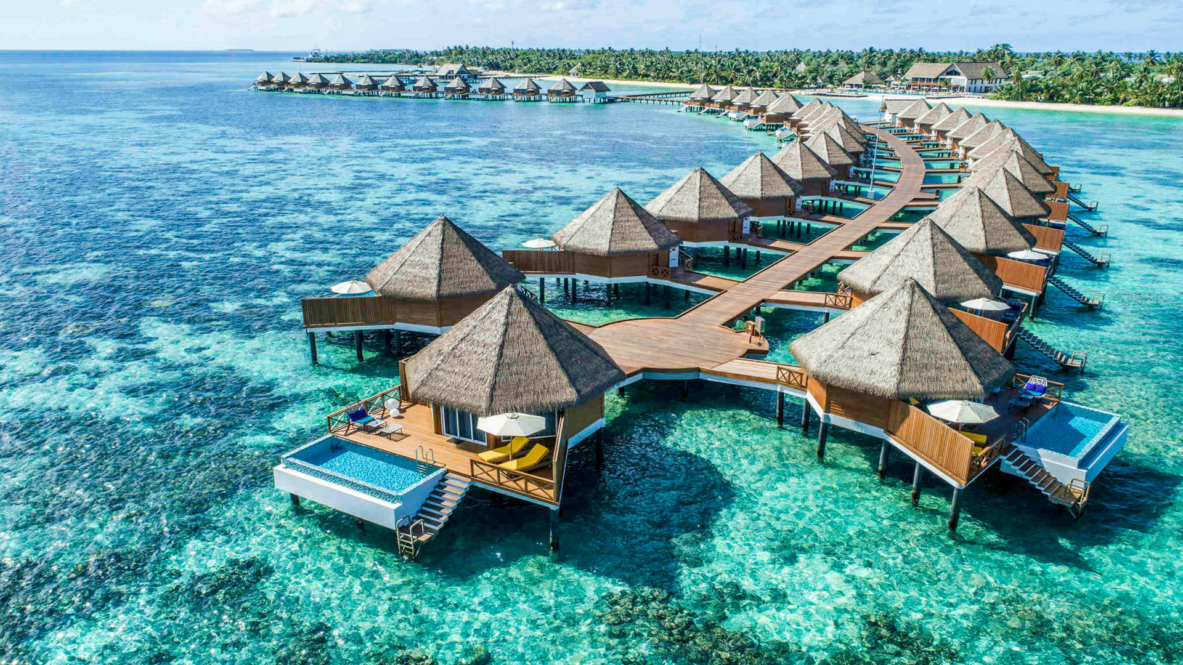Maldives is also known as “the tropical paradise”. The beauty it is magnificent . Maldives is a tropical country with many islands. Each island is surrounded by stunning sandy beaches. Everyone loves to explore the beauty of the islands.
The natural beauty lies in the Maldivian sea beats no other. There are over five thousand coral reefs and plenty of reef fish, corals, marine mammals, and so many other marine lives. And that is the reason people say, diving in Maldives is unforgettable.
Almost all the islands in Maldives are surrounded by beautiful pure white sandy beaches. Even if you have nothing else to do, I am sure you won’t get bored walking in the soft white sandy beaches and leaving your foot prints on.

Tour Itinerary

Day 1 : Arrival and ocean sightseeing
Pickup from Airport
The Maldives welcomes all tourist to its tropical paradise. The Maldives itself is an island country covered by an ocean in every side. After landing at the Maldives, Everyone will be traveling resort by a speedboat with great ocean sightseeing and check-in to your room. Spend the day relaxing and admiring the views of crystal clear waters sandy beaches.
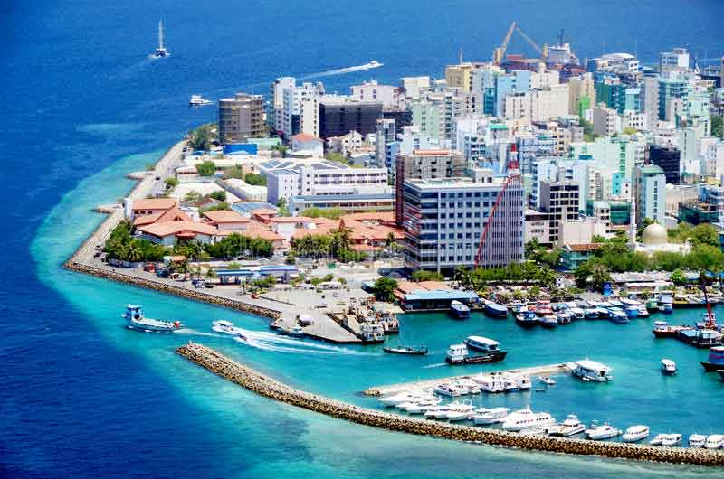

Day 2 : Self-personalized travelling
Breakfast, FREE Easy
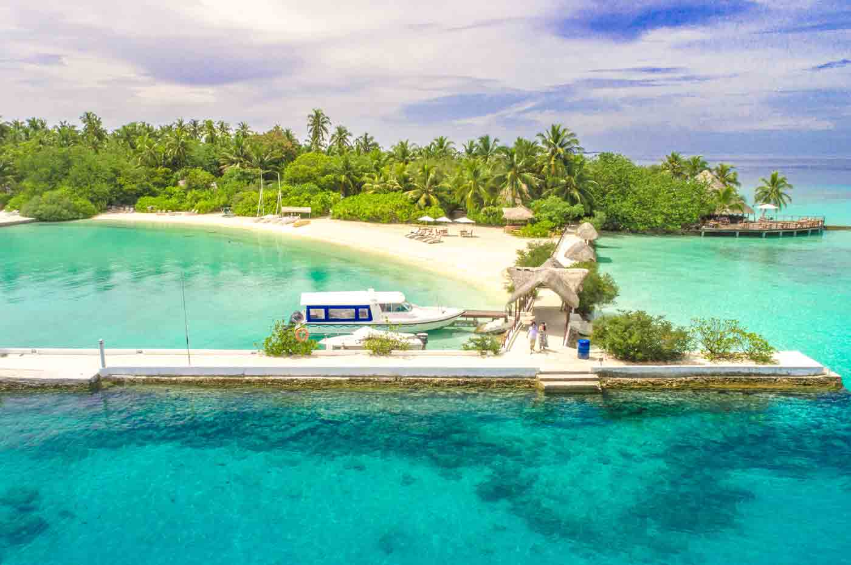

Day 3 : City tour & Candle light dinner in the Beach
Breakfast, City Tour, Candle Light Dinner in the Beach.
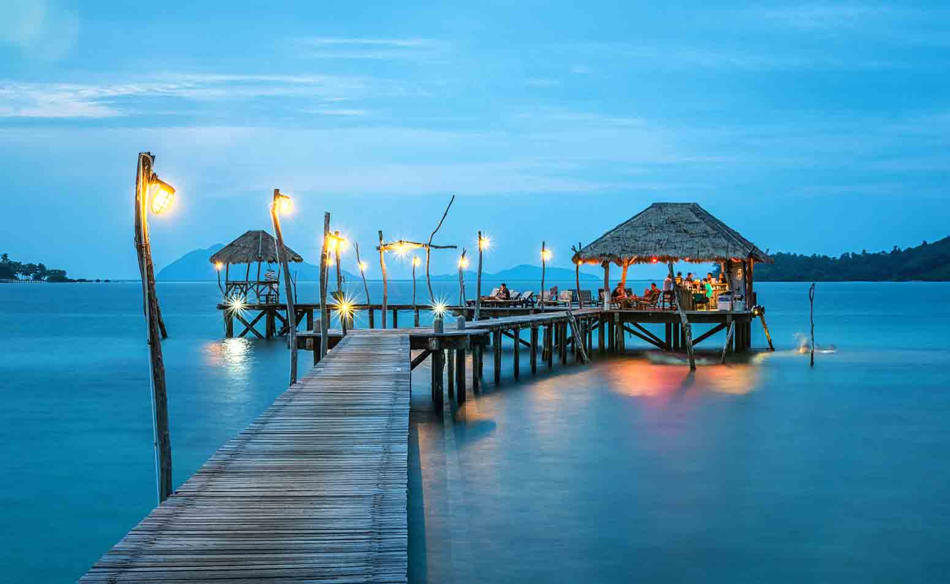

Day 4 : Departure
Ending the perfect day and a perfect tour, you will now be transferred to Milan Airport for your departure to home to your loved one.
Ending the perfect day and a perfect tour, you will now be transferred to Male Airport for your departure to home to your loved one.
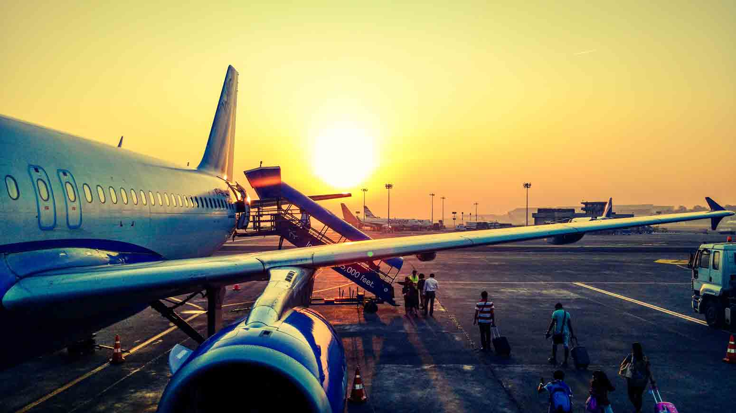

Inclusions
- Meet & Greet from Airport-Hotel-Airport
- Stay in Hulhumale Island / FREE & EASY for 3 Nights on BB Basis
- CITY TOUR + Candle Light Dinner in the Beach
- Airfare

