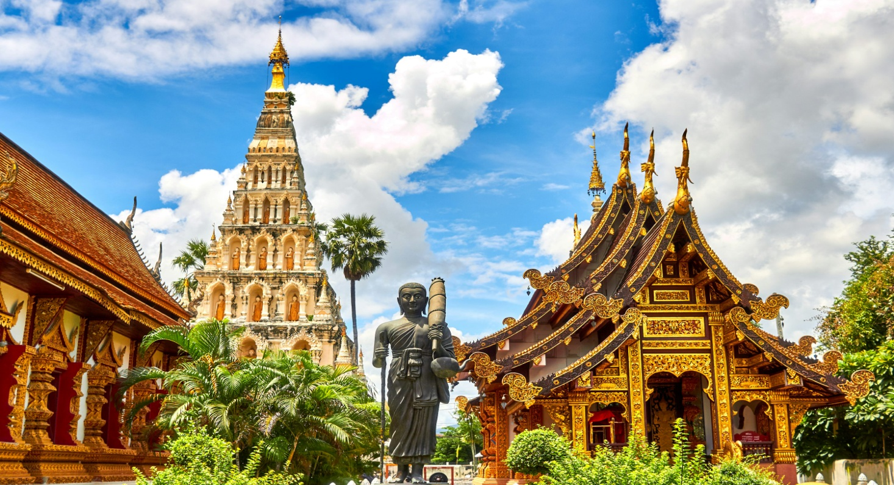AMAZING THAILAND
Get Ready For A 5 Day Pleasure At One Of The Wonder Destinations Of The World. This Beautiful Oriental Dream Never Stops With The Lush And Paradise, Because Of Which You Will Never Get Bored. So, Let's Put You On A Plane To Bangkok Drive You To The Pattaya's Sunny Beaches, Coral Island Tour And Then Enjoy City Tour At Bangkok Where You Get All Rejuvenated. With More To Exercise Being Your Companion In This Graceful Trip Of A Longer Period Where The Joy And Charm Never Stops.

Itinerary
Day 1: Arrive Bangkok & Transfer to Pattaya :
Welcome To Thailand!!! Orient's Most Fabled City. When You Arrive At The Suvarnabhumi International Airport Our Representative Will Be Next To The ATTA Counter (Gate No. 10; Counter C). You Will Then Be Transferred To Your Hotel On Seat In Coach Basis To Pattaya. Check In At The Hotel. Overnight At Your Hotel In Pattaya.
Day 2: Pattaya Coral island tour with Lunch:
After Breakfast In The Morning At Hotel, You Will Be Picked Up For A Speedboat Ride To The Coral Island. Upon Arrival You Will Be Treated To A Spectacular View Of The Island's Coral Reef On Board A Glass Bottom Boat. After Delicious Indian Lunch You Will Be Transferred To The Hotel. Overnight At The Hotel In Pattaya.
Day 3: Pattaya-Bangkok and city tour:
Enjoy Breakfast At The Hotel And Then Pick Up From The Hotel Lobby To Proceed For Bangkok. Today Enjoy Half Day City & Temple Tour Of Bangkok, Resplendent In All Of Its Fascinating Culture! Overnight At Your Hotel In Bangkok.
Day 4: Leisure for shopping and optional tour:
Enjoy Breakfast At The Hotel. The Rest Of The Day Is For Shopping / Optional Tours. Overnight At Hotel.
Day 5: Departure from Bangkok:
After Enjoying Breakfast At The Hotel, You Can Go For Some Last-Minute Shopping (As Per Your Flight Schedule). Check-Out And Take A Transfer To The Airport For Your Return Flight.

Includes
- Airport Picks Up And Drops.
- Coral Island Tour With Lunch In Pattaya
- City And Temple Tours At Bangkok.
- Daily Breakfast At Hotel.
- Transfer Bangkok Airport – Pattaya Hotel – Bangkok Airport

Excludes
- Other Beverage Throughout Trip.
- Expenses Of Personal Nature ( Tel Calls, Laundry, Porterage & Tips)
- Anything Not Mention In Itinerary

